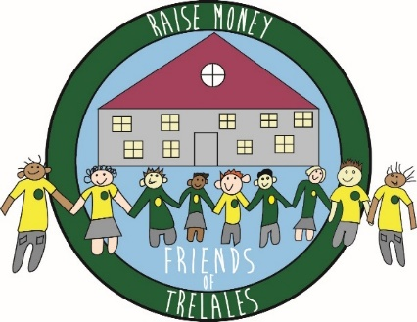

Registered charity number 1065545

The Friends of Trelales School is a registered charity that supports the learning environment for pupils at Trelales Primary School. We run several events throughout the school year, where we seek to raise money whilst also providing enjoyable, enriching experiences for the pupils. As they say, we work hard to put the ‘fun’ in FUNdraising!

Each year focuses on 4 types of activities:
- Discos: Halloween & Easter (Evening at-school); Family Dine & Disco
- In-school Pop-up Shops: Valentine’s Day, Mother’s Day & Father’s Day
- At-school Fayres/Fêtes: Christmas & Summer
- Online Sales: Christmas Cards, Badges, Class Photos, Water bottles, etc.

We also facilitate regular charity clothes collections through Dragon Bags, and organise Raffles, Silent Auctions and more as part of our live events.

Planning these activities and then making them happen on the day requires a lot of help. Our meetings take place at the Mackworth Arms Pub in Laleston on the first Tuesday of most months from 6:30-8 pm. Everyone in the wider Trelales Family is very welcome to pop by, say ‘hello’, and share their thoughts and ideas.
In addition to our meetings, we maintain a directory of volunteers that we can call on to help run stands at the large events: https://bit.ly/FOThelpers. Please take a moment to add your name to our list!
For more information on commonly asked questions, including how to contact us and how to stay up-to-date with our activities, please see our FOT-FAQ.
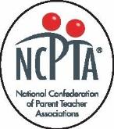

We’re eternally grateful to Trelales parents, guardians, teachers and staff, as well as the surrounding communities for their support over the years. With their help, in the 2022-23 school year, we helped purchase two large interactive screens, provided funds for classroom and club projects, and even helped pay for this new website enhancement. Here’s to another great year of FUNdraising ahead!

