Croeso yn ol i Ysgol Gynradd Trelales! A huge welcome to all our returning pupils and to all our new starters and their families, we are so excited to begin our learning journey for the 2024/25 academic year. I am thrilled to be a part of this wonderful community and look forward to getting to know you all. I am planning to hold an open evening in the coming weeks to introduce myself and some of the plans for the future.
A Journey of a thousand miles begins with a single step. (Lao Tzu)

Trelales Primary School Newsletter

Ysgol Gynradd Trelales

Shine Bright and Be your Brilliant Best!
  - Issue 1
6th September 2024
Mr Gibson


School Calendar – Dates for your Diary
Friday 27th Sept – Wednesday 2nd Oct – Book Fair open after school
Saturday 28th Sept – Sponsored swim
Tuesday 1st Oct – Parents’ Evening
Wednesday 2nd Oct – Parents’ Evening
Friday 11th Oct – Flu Nasal Vaccinations
Monday 14th Nov – Friday 25th Nov- Online Personalized Assessments Y2-Y6
Friday 15th Nov – Children in Need – Non-Uniform Day
Friday 20th Dec - Last day of Term.
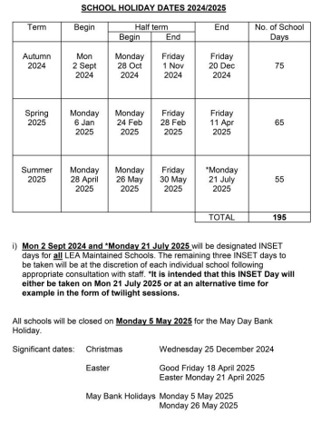


School Rules
Be Ready
Be Respectful
Be safe
We have introduced three school rules to help ensure we are all displaying the same brilliant behaviour in the school, at home and in the community. The rules are really dispositions that we should all adopt in order to ensure we are being the best version of ourselves we can be. Each class has then thought carefully about how we need to behave in order to uphold these rules. Every class has created a class charter, and the children have pledged to uphold this.


Scholastic Book Fair – Fri 27th Sep – Wed 3rd Oct
This year the Book Fair will run in a slightly different format. On the Friday, the children will have the chance to go and take a look at the books they would like. (No money is needed – this is just a chance to see what is there). On Tuesday and Wednesday, the Book Fair will be open AFTER SCHOOL. This is to align with Parents’ Evenings. Why not celebrate the children’s excellent start to the year by purchasing a book? The school receives a good percentage of the total we make, and this is put back into resources for the school. Last year, the money was used to purchase the Connector Series of books for the Home Reading Scheme


Sponsored Swim – Saturday 28th Sept
On Saturday 28th Sept at 4-5pm Trelales pupils and staff will be taking part in a fundraising swim (relay teams over 1 hour) to raise money for Trelales Primary and the Bridgend Lions, who support locally. More details to follow.

Parents’ Evenings – Tues 1st and Wed 2nd Oct
Correspondence regarding Parents’ evenings will come out shortly. This is a really important part of the school year where you can find out all the information about your child’s new class and get to meet the teacher.

Class Dojo / PE
Please make sure you have the Class Dojo App downloaded to keep up to date with the latest information for your class, such as; PE day, home learning and photos of the children’s learning. The messaging service is disabled so if you need to contact the teacher, you can email or call the school office. Remember that the children come to school in their PE clothes on their PE day. We encourage the wearing of black joggers, shorts or leggings, a yellow or white t-shirt, school jumper and appropriate footwear.

Clubs
There will be a range of clubs offered in the Autumn Term. These will take place either at lunchtime or after school. Look out for a club timetable and letter coming soon.
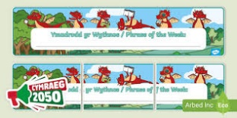
Welsh Phrase of the Week
In order to work towards our Bronze Award for the Siarter Iaith, we are introducing the ‘Phrase of the Week’. Help your child by practicing this at home.
W/B 9/9/24 – Sut wyt ti? How are you?
W/B 16/9/24 – Sut mae’r Tywydd? How’s the weather?

Breakfast Club
Breakfast club is open everyday for any child from Nursery to Year 6. Liz and Louise are asking if anyone has any toy donations for children aged 3-7 years old (particularly for girls).

If you have any questions or require further information about any of the contents of this newsletter, don’t hesitate to contact us at:
Admin.trelalesps@bridgened.cymru / 01656815611

