Trelales Primary School,

Well Street,
Laleston,
Bridgend,
CF32 0LF

Headteacher : Mr D. Gibson
Tel. 01656 815610
e-mail: head@trelalesps.bridgend.cymru
admin@trelalesps.bridgend.cymru

re. Change to the start and end of the day
Dear Parents and Carers,
To ensure a smooth start to the beginning of the day and ensure no children are stood waiting in the rain, we are changing the start of the day. All children will now come into school from the main playground.
The doors will open at 8.50am and the children can go straight into class. Year 4, 5 and 6 will go straight into their classrooms and the teachers will meet and greet on the door.
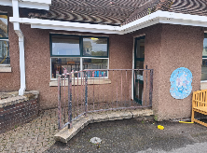
Year 2 and 3 will go in through the top side door.

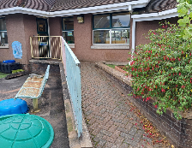
Year 1 will enter via the lower side door.

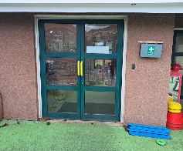
Reception will enter via the door into the classroom
Nursery entrance will stay the same.

The class teachers will be ready to meet and greet at the classroom door.
There is no need to line up on the yard, the children can come straight into class as soon as the doors open at 8:50am. The doors will be closed at 9am. After this time, any children who are late must report to the office and enter through there.
At the end of the day, the children will leave through the same doors they come through in the morning. This means the start and end of the day will all take place on the main playground. This change will take effect on Monday 16th September. I look forward to welcoming you back onto the school grounds. If you have any questions, please don’t hesitate to contact or chat in the morning.
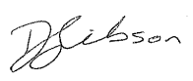
Yours sincerely,

Damon Gibson
Head Teacher

