Welcome to the sixth edition of our newsletter. With the Christmas Fair and Concerts well under way school is a hive of excitement at the moment. The children are all busy learning their lines and actions as well as making incredible products to sell at the fair.
Issue 6
29th November 2024
Be Brave. Take Risks. Nothing Can Susbstitute Experience.
Paulo Coelho
Trelales Primary School Newsletter
Ysgol Gynradd Trelales

Shine Bright and Be your Brilliant Best!
I am looking forward to my first Christmas Fair at Trelales. Friday 15th November was Children in Need and we ended up raising a massive £1447. A huge thanks to Mrs Lewis and the children in Year 6 for organising the activities and for everyone for their donations. Congratulations to Year 2 for winning the talent show and to the Hammacott family for their sensational Showstopper in the Big Bake competition.

The school is looking to host some parent workshops in the New Year, one aimed at maths support and another accredited session of our choosing. We will be sending a poll out soon for the suggested classes and we will try to host the most popular one.
The kitchen extension works are due to begin in mid February and be completed by mid June. Further updates as to how this will affect the school will be provided as we have them.

The school has a vacancy for a parent governor, we will be hoping to elect this member next year.

Some sad news to finish this part of the Newsletter…
After Christmas we will be saying goodbye to Mrs Emma Lewis and Mrs Jill Evans. Mrs Lewis is going on to work for Bridgend County Borough Council as a Play Therapist and Mrs Evans is taking early retirement. Both have been wonderful servants of the Trelales School Community and we wish them well in their future endeavours.

Mr Gibson

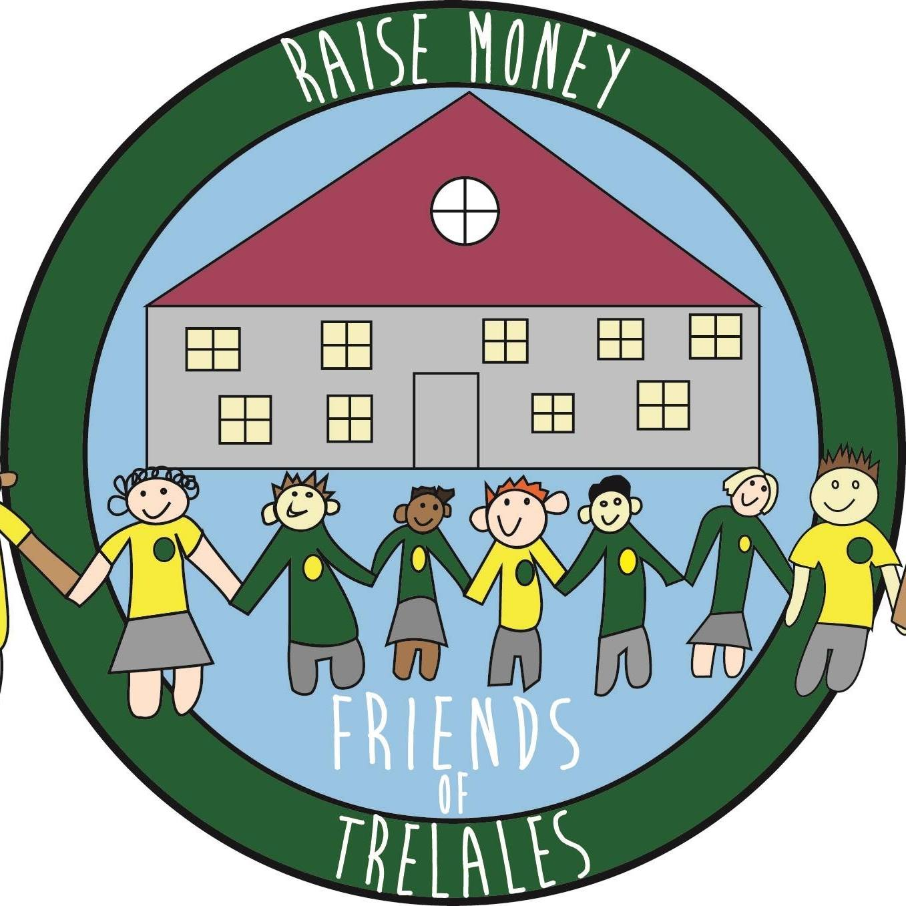
Friends of Trelales
Friendly reminder from the FOT:
Please help us raise as much money as we can for our fabulous school and children by:
1) Checking out our amazing silent auction prizes and bid bid bid.
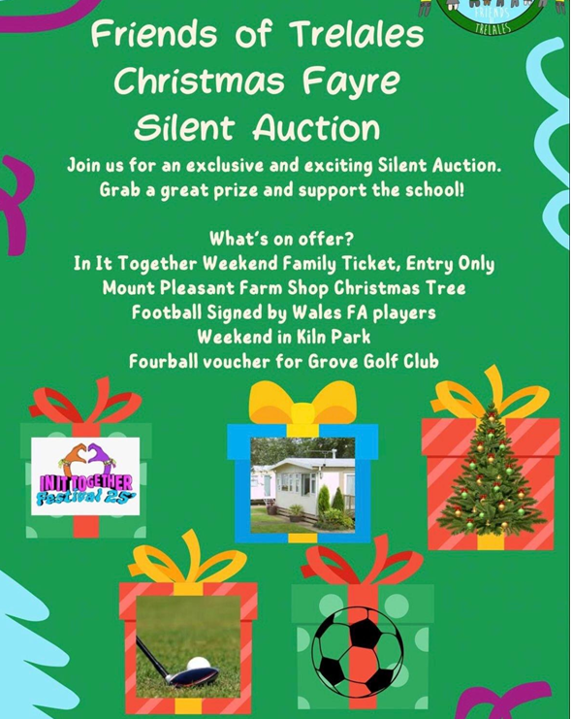
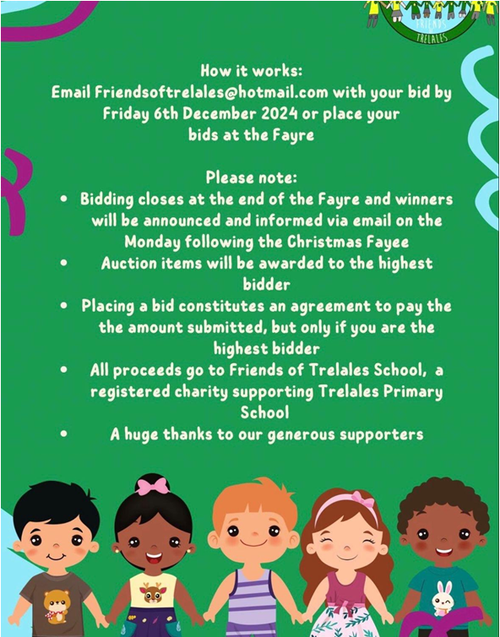
2) Sell, sell, sell as many raffle tickets as you can - amazing prizes have been donated. Please return stubs, money and any unsold tickets to the office by no later than 4th December 2024.

3) Please donate the following by leaving at reception by 2 December 2024:
- Unopened bottles in a bottle bag for our tombola;
- Teddies and soft toys in good condition;
- Mince Pies.

4) Come along to the Winter Fayre on 6th December 2024 from 2.30pm. There are external stalls, food, drinks, glitter tattoos, fun activities and our children will be selling their own made enterprise items. Volunteers are needed and would be welcomed to lend a hand. If you are able to spare any time, please let us know via the link:
https://docs.google.com/spreadsheets/d/1O5RQC05ZMyLF-fro71aBqrZYMGclUPsTPSCdG8tdrLU/edit

5) Tokens are available at reception. Cash and card will also be accepted at the Fayre.


Thank you for your continued support.


School Calendar – Dates for your Diary
Tuesday 3rd Dec - School Photo ‘mop up’ for those pupils missed or away
Tuesday 3rd Dec - Governing Body meeting @4pm
Thursday 5th Dec- Nursery trip to see Santa at Wiggleys
Friday 6th Dec - 2.30pm - Christmas Fair
Monday 9th Dec - Yr 4, 5, 6 Christmas concert @ 1.30pm and 6pm
Tuesday 10th Dec - N, R Christmas concert @1.30pm and 5pm
Wednesday 11th Dec - Pantomime for Rec-Y6 in Swansea
Thursday 12th Dec - Yr 1, 2 and 3 Christmas Concert @ 1.30pm and 6pm
Friday 13th Dec - Sockittous day - £1 donation
Saturday 14th Dec - Christmas Tree Festival @ Nolton Church. Choir and guitars at 11am
Monday 16th Dec - Choir performing at Oaklands
Wednesday 18th Dec - Christmas Dinner day
Thursday 19th Dec - Carol service for children at the church @ 9.30am and 10.30am
Thursday 19th Dec - Mr Warmby’s Pantomime @ 1.30pm
Friday Dec 20th - Last day of Term.
Monday Jan 6th - First day of Spring Term
Friday 20th January - INSET day - school closed to children

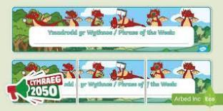
Welsh Phrase of the Week
In order to work towards our Bronze Award for the Siarter Iaith we are introducing the phrase of the week. Help your child by practising this at home.
W/B 02/12/24 – Mae hi’n amser cinio / mynd adre / chwarae. It’s dinner / home / play time.
W/B 09/12/24 – Nadolig Llawen a blwyddyn newydd dda.

Asda Cashpot for schools
The school has signed up to the Asda Cashpot for Schools initiative. The last day of this is 30th November. If you shop at Asda, please link your points with Trelales so we can raise as much money as possible to keep supplying resources for the benefit of all the children. use the link for more information: https://www.asda.com/cashpotforschools


Your school needs you!
As mentioned, the Big Dig was a huge success but the school always needs your help. There are so many ways in which parents, grandparents and other family members can get involved such as: coming into school, hands on with school ground developments, grant searching and applying, any business links, offering any skills based activities that could support the school or curriculum, support for after school clubs, members of community groups etc. Please fill out the letter attached if you haven’t already done so.


Pantomime - Swansea Grand Theatre
This year, on the 11th December, the children from Reception to Year 6 will be going on a trip to Swansea to Watch Jack and the Beanstalk. Please can you ensure you have signed the consent form and paid via School Money, the cost is £20 per child which covers the ticket and transport to and from the theatre. The show starts at 10am and finishes at approximately 12pm. This means that a packed lunch will need to be provided for the children.


Sockittous ( sock it to us) day

This year we are supporting a fantastic small charity Kids Cancer Charity. They have been offering invaluable help and support to one of our families and we thought it would be good to make them a partner charity to help whenever we can. The first way is to wear your Christmas socks and donate a minimum £1. Every £500 raised helps to send a family on a luxury caravan break on theWelsh Coast for a well deserved break from treatment regimes.
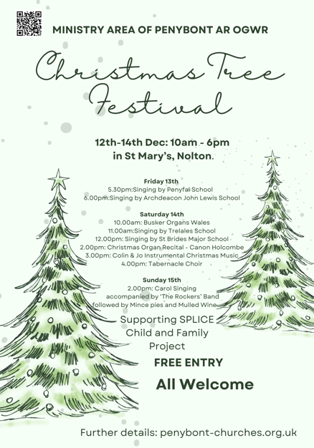
Christmas Tree Festival
Come and join us at the Christmas Tree Festival in St Mary’s Church in Nolton, Year 6 have been working on a Tree for the school and our fabulous choir and guitar group will be playing.
You can visit the festival at any time from Thursday 12th to Sunday 15th. We are performing at 11am on Saturday. Hope to see you there.

Family Engagement officer and Early Help.
Early Years and Young People Support Services
Bridgend County Borough Council has a service for families and organisations to refer to if they feel they need support with a range of concerns. The following link will take you to the webpage for further information. Our school has a family engagement officer who visits once a week, her contact details are on the flyer.
Bridgend Early Help Services - Bridgend CBC
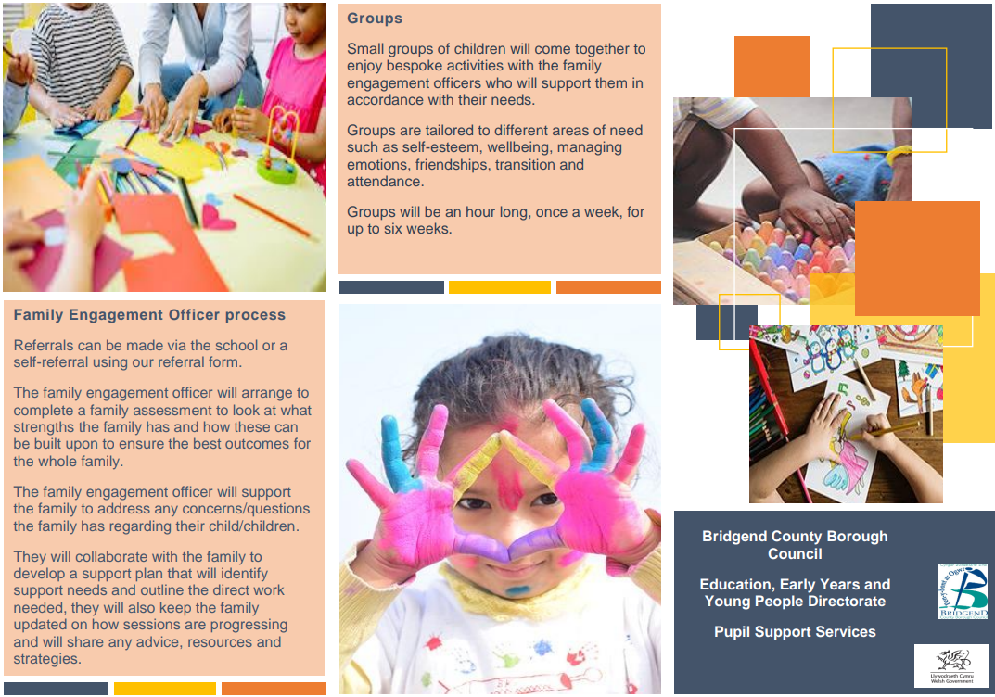
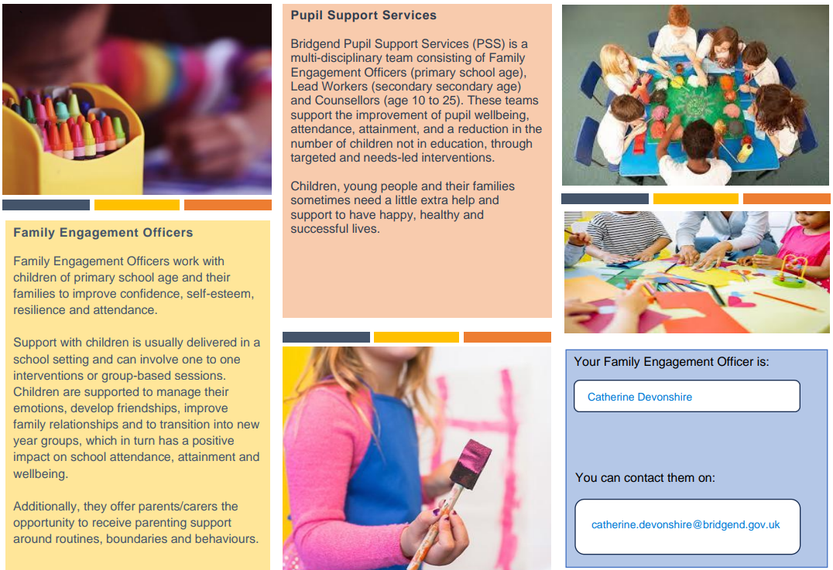
If you have any questions or require further information about any of the contents of this newsletter, don’t hesitate to contact us at: Admin.trelalesps@bridgened.cymru / 01656815611

