Welcome to the seventh edition of our newsletter. What an amazing couple of weeks we have had! The choir has been performing in the community as have our guitar trio ‘Miscellaneous’. Both will be performing again on Saturday at St Mary’s Church in Nolton at the Christmas Tree Festival at 11 am, so please come along and support them. Our Winter Fair was a huge success. The children had worked so hard designing and making products, working out profit and costings, as well as marketing and advertising. The children have made over £900!! Each class gets to keep the money they made and will now decide what they want to use it for. The FOTs members worked tirelessly to bring us a wonderful Winter Fair which made over £2000. Meaning our total as a school is approximately £3000!!!
Issue 7
13th December 2024
Nadolig Llawen
May we never be too grown up to search the skies on Christmas Eve
Andrew Gilbert
Trelales Primary School Newsletter
Ysgol Gynradd Trelales

Shine Bright and Be your Brilliant Best!

The Christmas concerts have been amazing. The children have been wonderful and have started the Christmas season off in style. Nursery and Reception brought us the wonderful Wriggly Nativity, fantastic singing and beautiful loud voices on stage!
Year 4, 5 and 6 put on the charming ‘When Sasha got swept up the chimney - this was a rollercoaster of emotions. There were enough Christmas jokes to fill an entire book!
And finally Years 1, 2 and 3 gave us ‘You Are Special’. A heartwarming tale of believing in yourself, ‘The dots only stick if you let them’. A beautiful message for us all about self worth and not worrying about what others think.

I would like to say a huge thank you to all our wonderful families for the support you have given the school over my first term at Trelales Primary School. I already feel honoured to be the head teacher of this wonderful community. May you all have a wonderful Christmas break and I look forward to seeing you all in the New Year.


Mr Gibson
Until then, Nadolig Llawen a Blwyddyn Newydd Dda.


School Calendar – Dates for your Diary
Saturday 14th Dec - Christmas Tree Festival @ Nolton Church. Choir and guitars at 11am
Monday 16th Dec - Choir performing at Oaklands
Tuesday 17th Dec - Community Carol Service @ St David’s Church 6pm
Wednesday 18th Dec - Christmas Dinner day
Thursday 19th Dec - Carol service for children at the church @ 9.30am and 10.30am
Thursday 19th Dec - Mr Warmby’s Pantomime @ 1.30pm
Friday 20th Dec - Last day of Term.
Monday Jan 6th - First day of Spring Term
Friday 10th Jan - CAVMS (Cardiff and Vale Music Service) assembly.
Monday 20th Jan - INSET day - school closed to children
Tuesday 21st - Friday 24th Jan - Year 3 and 4 Swimming Lessons @ Pyle
Monday 27th - Friday 31st Jan - Year 5 and 6 Swimming Lessons @ Pyle
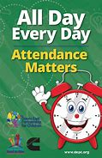
Attendance - Whole School Target 95%
Attendance remains one of the authorities key priorities. In the New Year, we will be notifying all parents of their child’s percentage attendance for the first term. These letters are for information only. We work closely with all families and our Education Welfare Officer who monitors attendance in our school, and will seek to work with anyone who is finding attendance a concern. Our attendance has been fantastic this term (apart from the last few weeks when the Laleston Virus has caught us), our overall attendance is 94%
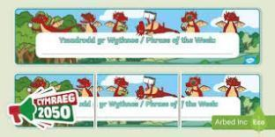
Welsh Phrase of the Week
In order to work towards our Bronze Award for the Siarter Iaith we are introducing the phrase of the week. Help your child by practising this at home.

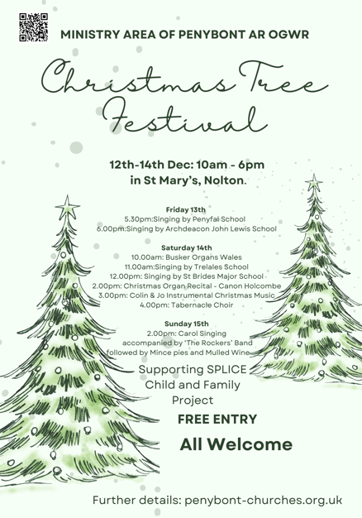
W/B 16/12/24 – Nadolig Llawen a blwyddyn newydd dda.

Christmas Tree Festival
Come and join us at the Christmas Tree Festival in St Mary’s Church in Nolton, Year 6 have been working on a Tree for the school and our fabulous choir and guitar group will be playing.
You can visit the festival at any time from Thursday 12th to Sunday 15th. We are performing at 11am on Saturday. Hope to see you there.
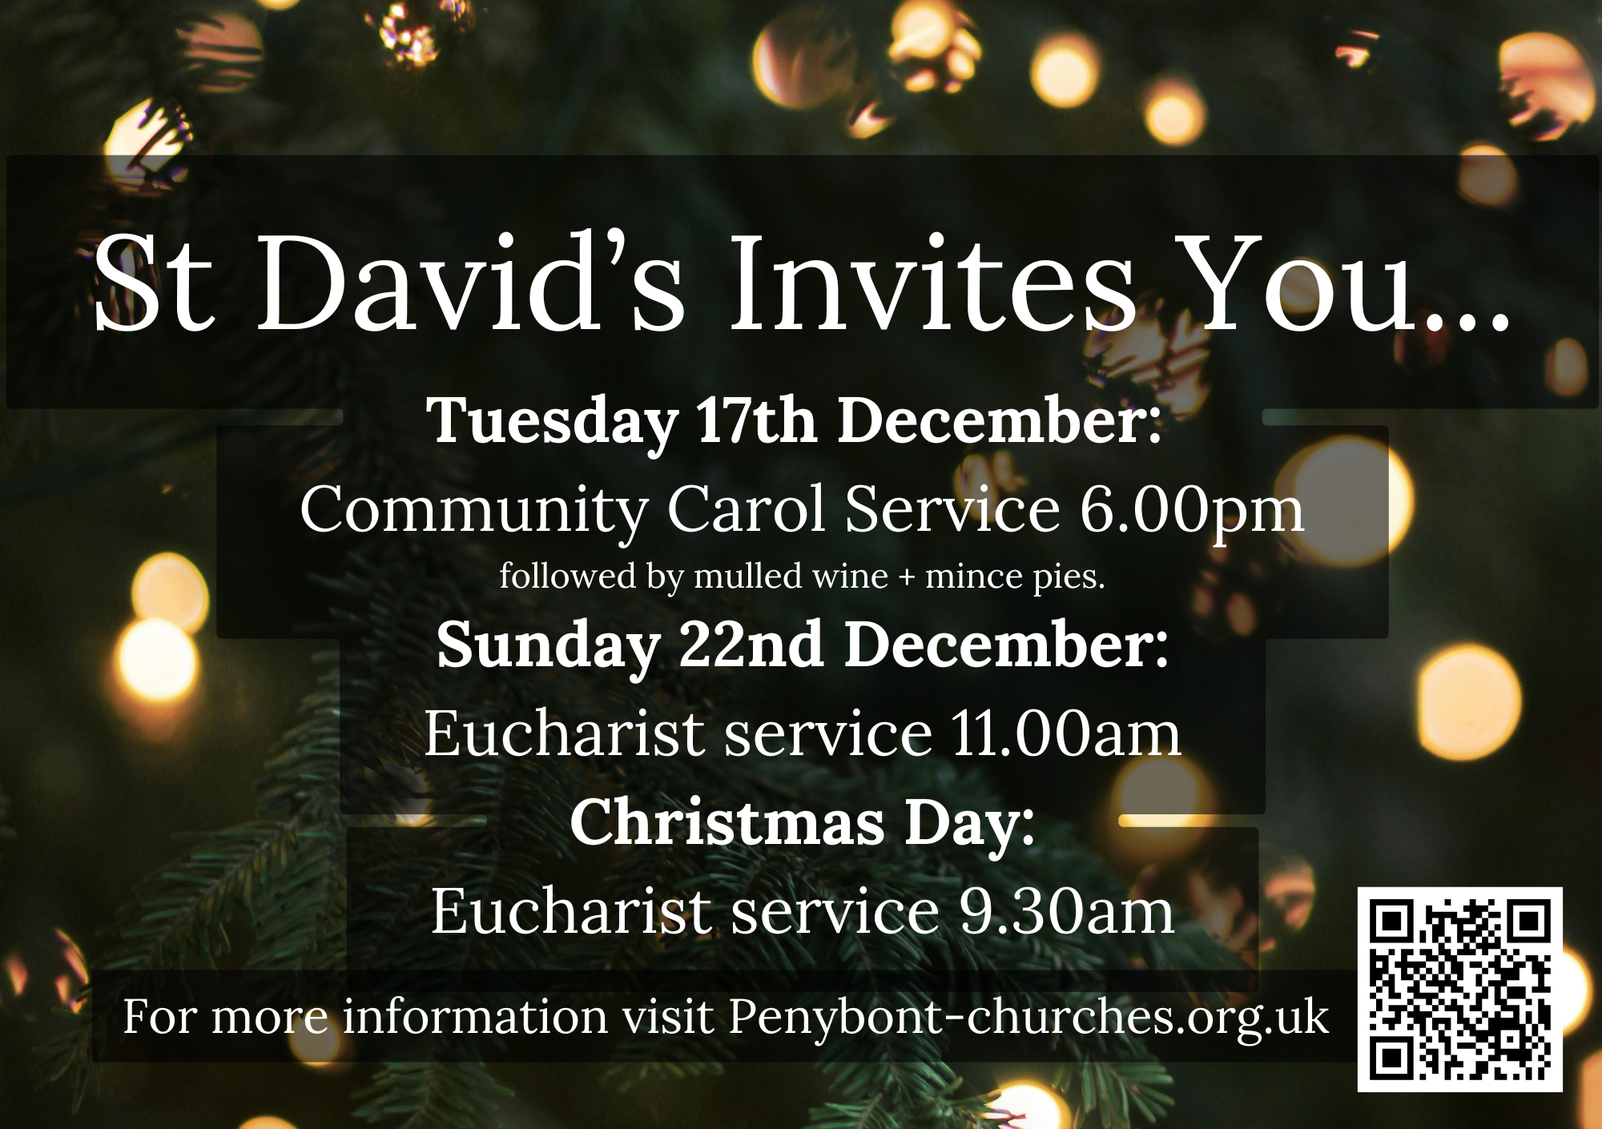
Community Carol Service @ St David’s Church
Tuesday 17th December is Laleston Community Carol Service. Please come along from 6pm, it would be lovely to see lots of families.

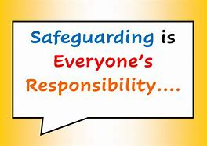
Safeguarding
Children’s welfare and wellbeing is at the heart of everything we do at Trelales.
Every person who works in the school has to have a DBS certificate and has annual training. The school’s safeguarding lead is Mr Gibson and deputy lead is Mrs Fitzgerald. If you have any concerns please raise them with a member of staff.
If you have concerns out in the community you can call MASH (Multi Agency Safeguarding Hub) on 01656 6422320. Alternatively, you can use this link to the website: Safeguarding

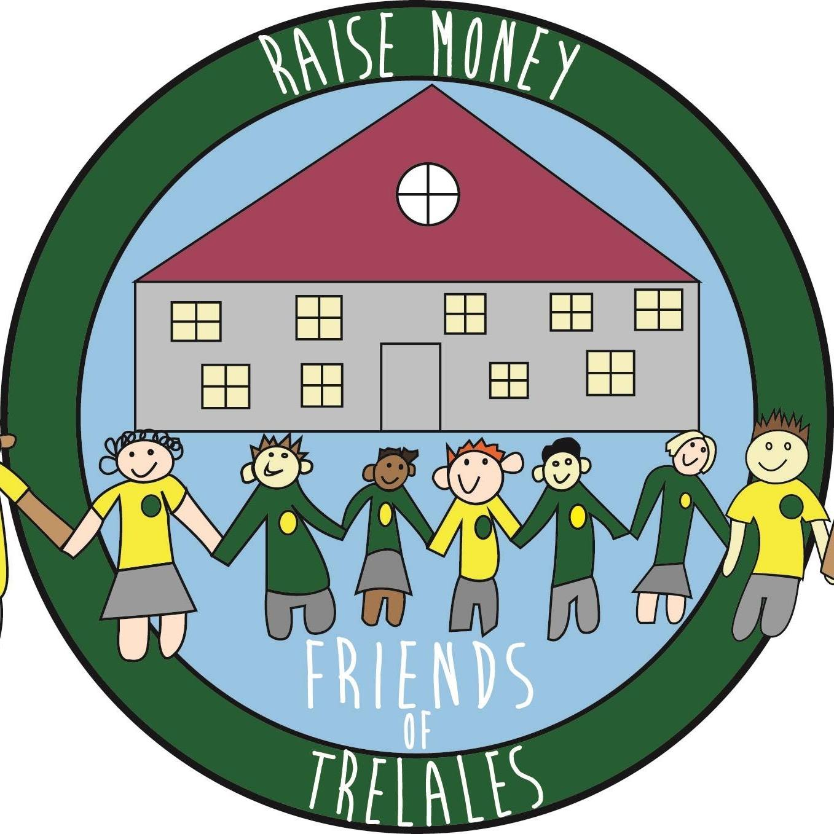
Friends of Trelales
Friends of Trelales would like to say a huge THANK YOU to everyone involved in helping make the Trelales Winter Fayre such a huge success. So much fun was had by all and it raised much needed funds for our fabulous school.

We would like to thank:
- all the children, parents, families and local community who attended, volunteered their time and donated so generously. We are so so grateful;
- the stall holders who attended and provided us with such amazing local products;
- all those amazing companies who provided amazing and generous prizes for both the raffle and silent auction - they were truly fantastic.
- last, but by no means least, the fabulous teacher and support staff of our amazing school who have worked tirelessly before, during and after the event. Your help, time and efforts have greatly assisted in making the event such a success.
We will provide an update of the funds raised at a later date but for now, we wanted to say thank you!
We wish you a very Merry Christmas and look forward to working together with you all in.

Family Engagement officer and Early Help.
Early Years and Young People Support Services
Bridgend County Borough Council has a service for families and organisations to refer to if they feel they need support with a range of concerns. The following link will take you to the webpage for further information. Our school has a family engagement officer who visits once a week, her contact details are on the flyer.
Bridgend Early Help Services - Bridgend CBC
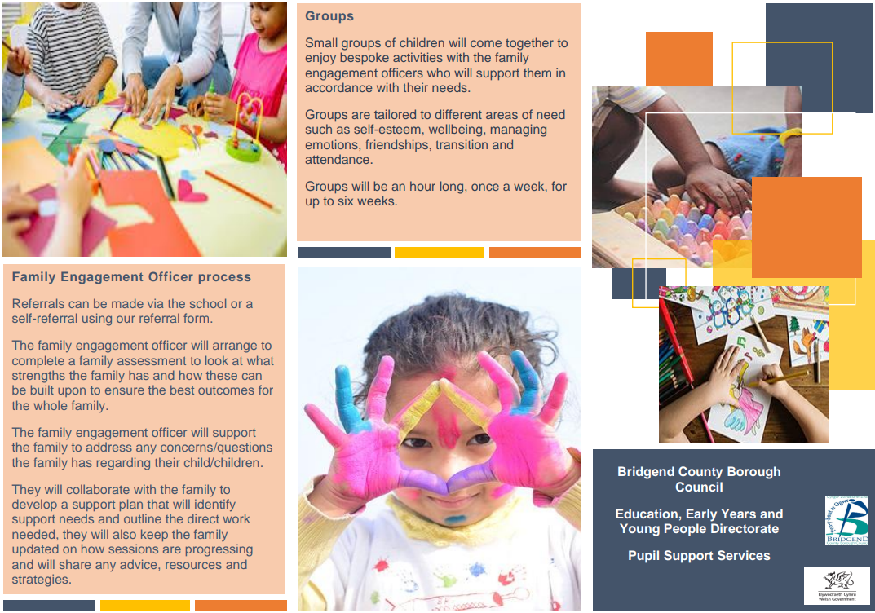
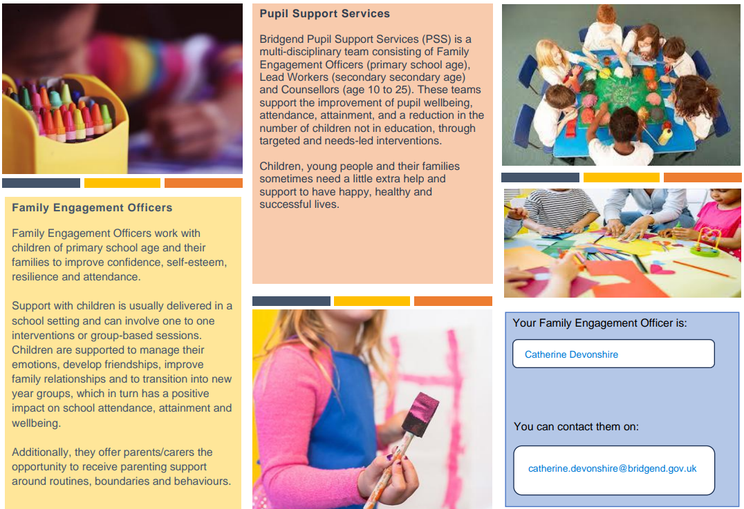
If you have any questions or require further information about any of the contents of this newsletter, don’t hesitate to contact us at: Admin.trelalesps@bridgened.cymru / 01656815611

