Welcome to the ninth edition of our newsletter. Thank you to the parents who have signed up to the Parent’s Numeracy session taking place on the 6th February after school. We have had 24 sign up to the 2 hour course! There will be an additional 4 hour first aid course in the near future. We will be offering a weekly Homework club for numeracy support and fun (also on a Thursday, starting on 13th February). These places will initially be offered to the children of the parents signed up to the course. If these are not all taken then we will open it up to the wider school community.
Issue 9
31st January 2025
Love challenges, be intrigued by mistakes, enjoy effort and keep on learning.
Carol Dweck
Trelales Primary School Newsletter
Ysgol Gynradd Trelales

Shine Bright and Be your Brilliant Best!
All children from Year 3 to 6 have embarked on swimming lessons over the last fortnight. We have received so many comments and compliments from the staff and members of the public on the children’s fantastic behaviour and attitude, which is wonderful to hear.
A big thank you to Simon Brooks who has been giving up his weekends to help further develop the pond area in the school.

British STEM Week (Science, Technology, Engineering and Maths) is taking place between 10th and 14th March. We are hoping to have an action packed week with activities based around the theme of Change and Adapt. As part of this, we would love to arrange visitors who have knowledge and skills in these areas. If you work for a company or are able to come along and do some activities / sessions with the children, we would love to hear from you.

Mr Gibson


School Calendar – Dates for your Diary
Thursday 6th Feb - Multiply Numeracy Project - 2 hour parents numeracy session after school
Thursday 13th Feb - Thursday 10th April - Numeracy Homework fun and games
Monday 24th - Friday 28th February - Half Term
Thursday 27th February - Multiply Festival - Archbishop McGrath School
Friday 7th March - School Eisteddfod
Monday 10th - Friday 14th March - STEM Week
Monday 24th March - Parent’s Evening
Tuesday 25th March - Parent’s Evening
Wednesday 26th March - Parent’s Evening
Friday 4th April - Year 6 to Crucial Crew
Friday 11th April - LAst day of Spring Term
Monday 7th - Wednesday 9th July - Year 6 Residential to Llangrannog.

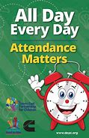
Attendance - Whole School Target 95%
Last week’s whole school attendance was 95.8% with four classes each sharing first place with 100% attendance. Llongyfarchiadau bawb. Year 3 are the current half termly attendance champions and the proud owners of Mr. Gibson’s smelly sock (they also had a £20 voucher for the class as well!)

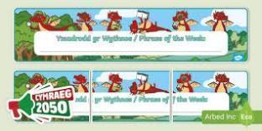
Welsh Phrase of the Week
In order to work towards our Bronze Award for the Siarter Iaith we are introducing the phrase of the week. Help your child by practising this at home.

W/B 3/2/25 - Dwi’n wedi gorffen! I am finished.
W/B 10/2/25 - Mae hi’n amser cinio – It is dinner time!

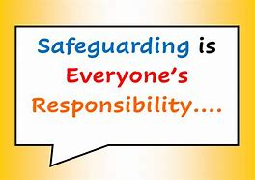
Safeguarding
Children’s welfare and wellbeing is at the heart of everything we do at Trelales.
Every person who works in the school has to have a DBS certificate and has annual training. The school’s safeguarding lead is Mr Gibson and deputy lead is Mrs Fitzgerald. If you have any concerns please raise them with a member of staff.
If you have concerns out in the community you can call MASH (Multi Agency Safeguarding Hub) on 01656 6422320. Alternatively, you can use this link to the website: Safeguarding

School Meals
As I am sure you are aware, School meals are free for pupils in Wales. We will be on Week 2 of the menu next week. You can find the menu on the school website.

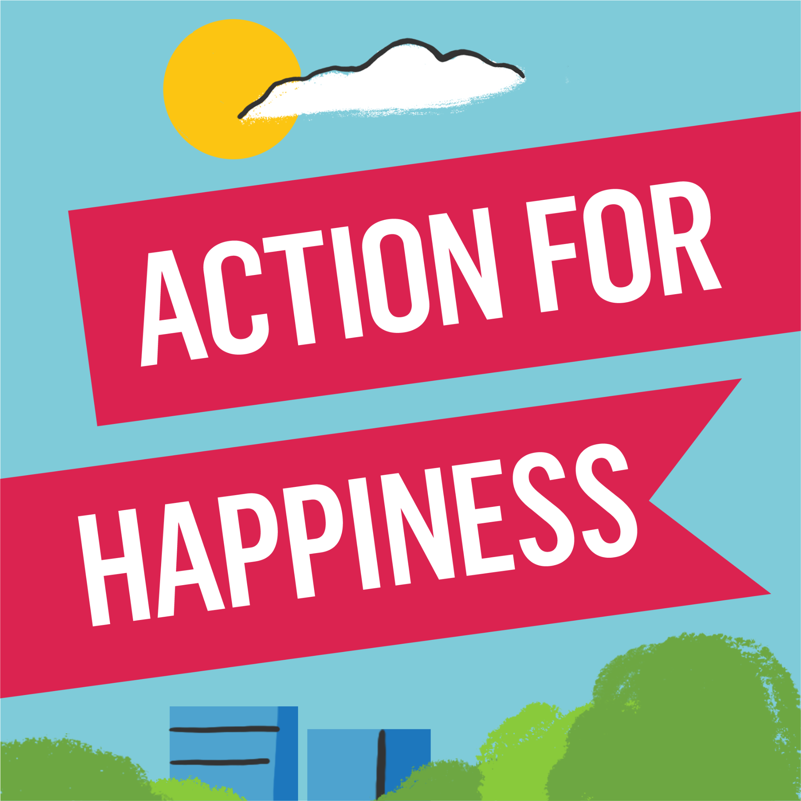
Action for Happiness
Every month the children look at one of the 10 keys to happiness which are 10 ways of being which can help us to be happy. The actions and mindsets themselves release positive chemicals in our brains and body called oxytocin, endorphins, serotonin and dopamine amongst others. We learn about these in assembly and then try to practise them through the month. Next month’s value is Trying Out.
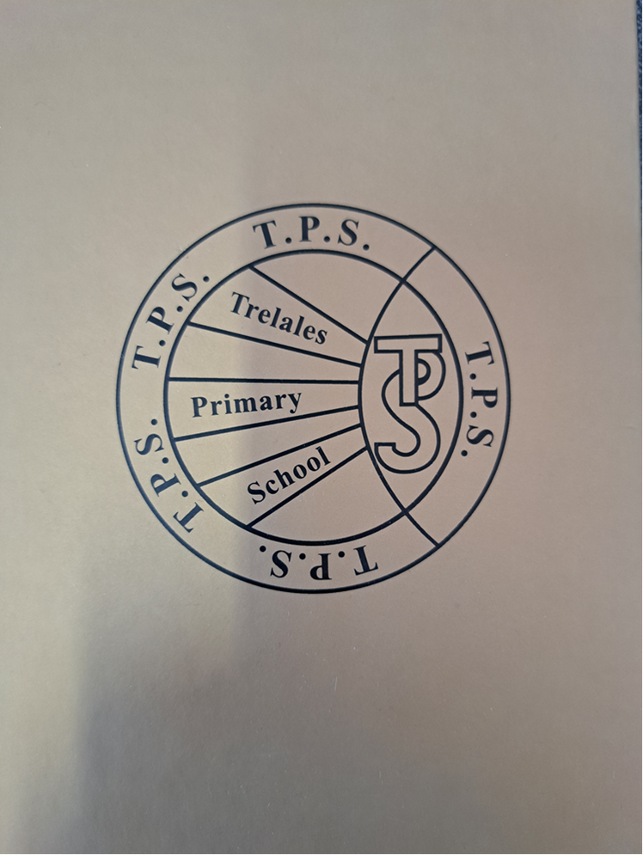
Value of the Month - The Golden Book
Similarly, we have a value of the month. There are eleven Trelales Values which the children decided upon at the beginning of the school year. We focus on one a month as well. Again, we discuss it in assembly and then build it into the months learning activities and celebrate the children practicing these values. At the end of every half term. One person is chosen from each class to be entered into the Golden Book, this child is someone who has demonstrated these values over and over again. The Values focused on this half term are Positivity and Gratitude.

Multiply Project - Multiply Festival
Our Multiply Numeracy Project begins next Thursday but we have been asked to tell you about a festival of fun activities during half term. The Multiply Festival of Numeracy takes place at Archbishop McGrath School Sports Hall on Thursday 27th of February, from 12pm-3pm. This is a fun free event for adults and children to enjoy in half term.
Please reserve your tickets asap via Eventbrite!
Link to Eventbrite: https://www.eventbrite.co.uk/e/1116703443059?aff=oddtdtcreator

The event is to celebrate the success of the Multiply Project in Bridgend, they are inviting along past and present participants on the Multiply project as well as the general public.

This event will feature a number of companies that we have worked with over the course of the project to put on one big free fun day that will feature activities such as:

Mini Golf, Inflatable Football Darts, PIING Games, Mad Science, Mathmagics, Cookstars, a Circus Performer, arcade games and much more! Multiply is a free adult numeracy skills project in Bridgend that has helped over 800 people in Bridgend to improve their maths skills, gaining confidence and qualifications.
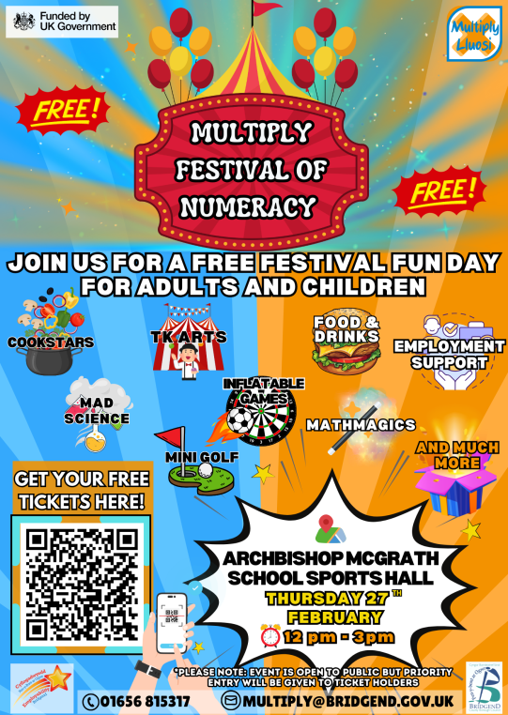

Family Engagement officer and Early Help.
Early Years and Young People Support Services
Bridgend County Borough Council has a service for families and organisations to refer to if they feel they need support with a range of concerns. The following link will take you to the webpage for further information. Our school has a family engagement officer who visits once a week, her contact details are on the flyer.
Bridgend Early Help Services - Bridgend CBC
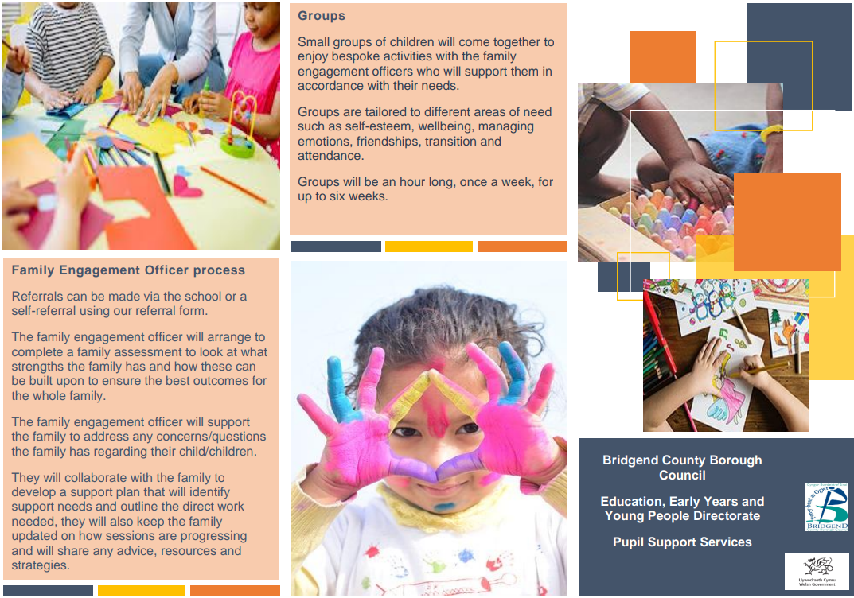
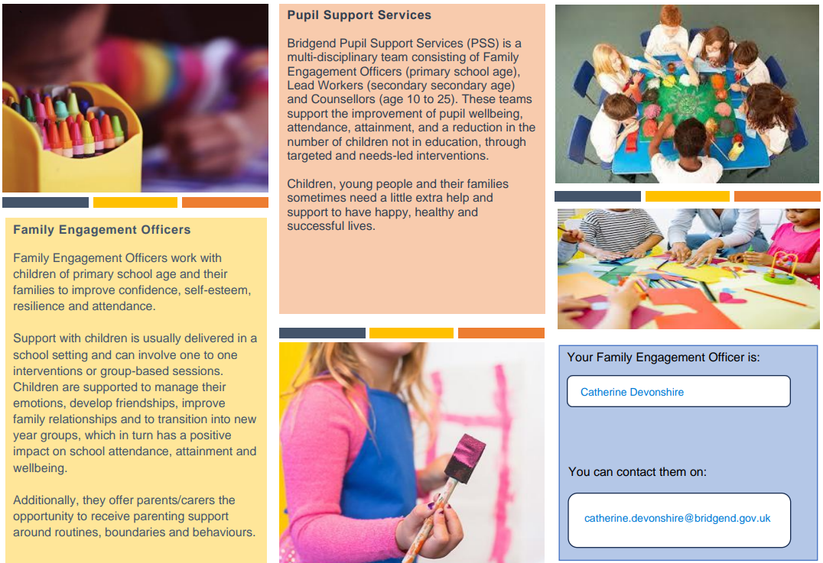
If you have any questions or require further information about any of the contents of this newsletter, don’t hesitate to contact us at: Admin.trelalesps@bridgened.cymru / 01656815611

