Welcome to the eighth edition of our newsletter. Croeso i nol to the new school term. It already seems super busy. We have our Parent’s Numeracy session taking place on the 6th February after school, followed by weekly Homework club for numeracy support and fun. More details to follow about how to sign up for these.
Issue 8
17th January 2025
We are only limited by the scope of our own imagination.
Damon Gibson
Trelales Primary School Newsletter
Ysgol Gynradd Trelales

Shine Bright and Be your Brilliant Best!
We welcome Mr Phillps and Miss Dyke to our team temporarily whilst Mrs Morris is recuperating. Building work on the new kitchen won’t be starting until March but I will keep you updated with how this is progressing.
Children from Year 3 to 6 will be embarking on swimming lessons over the next fortnight as well. We are still looking at ways to develop the school and for any parents who would like to be more involved in school life. There are forms in the office to fill out.

We aim to organise another community day in school this term (similar to the Big Dig day but maybe indoors!) Look out for updates on this. We would love to see as many parents and family members as possible joining us for the day.

Mr Gibson


School Calendar – Dates for your Diary
Friday 17th Jan - Rugby and Netball Games @ Trelales v Newton
Monday 20th Jan - INSET day - school closed to children
Tuesday 21st - Friday 24th Jan - Year 3 and 4 Swimming Lessons @ Pyle
Monday 27th - Friday 31st Jan - Year 5 and 6 Swimming Lessons @ Pyle
Thursday 6th Feb - Multiply Numeracy Project - 2 hour parents numeracy session after school
Thursday 13th Feb - Thursday 10th April - Numeracy Homework fun and games
Monday 24th - Friday 28th February - Half Term
Friday 7th March - School Eisteddfod
Monday 10th - Friday 14th March - STEM Week
Tuesday 25th March - Parent’s Evening
Wednesday 26th March - Parent’s Evening
Friday 4th April - Year 6 to Crucial Crew
Friday 11th April - LAst day of Spring Term
Monday 7th - Wednesday 9th July - Year 6 Residential to Llangrannog.

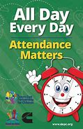
Attendance - Whole School Target 95%
Attendance remains one of the authorities key priorities. In the New Year, we will be notifying all parents of their child’s percentage attendance for the first term. These letters are for information only. We work closely with all families and our Education Welfare Officer who monitors attendance in our school, and will seek to work with anyone who is finding attendance a concern. Our attendance has been fantastic this term (apart from the last few weeks when the Laleston Virus has caught us), our overall attendance is 94%

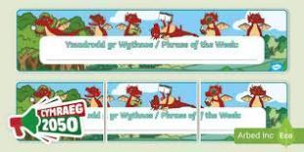
Welsh Phrase of the Week
In order to work towards our Bronze Award for the Siarter Iaith we are introducing the phrase of the week. Help your child by practising this at home.

W/B 3/2/25 - Dwi’n wedi gorffen! I am finished.
W/B 10/2/25 - Mae hi’n amser cinio – It is dinner time!

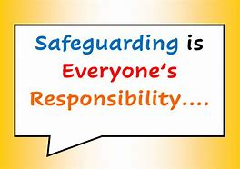
Safeguarding
Children’s welfare and wellbeing is at the heart of everything we do at Trelales.
Every person who works in the school has to have a DBS certificate and has annual training. The school’s safeguarding lead is Mr Gibson and deputy lead is Mrs Fitzgerald. If you have any concerns please raise them with a member of staff.
If you have concerns out in the community you can call MASH (Multi Agency Safeguarding Hub) on 01656 6422320. Alternatively, you can use this link to the website: Safeguarding

School Meals
As I am sure you are aware, School meals are free for pupils in Wales. We will be on Week 3 of the menu next week. You can find the menu on the school website.

Family Engagement officer and Early Help.
Early Years and Young People Support Services
Bridgend County Borough Council has a service for families and organisations to refer to if they feel they need support with a range of concerns. The following link will take you to the webpage for further information. Our school has a family engagement officer who visits once a week, her contact details are on the flyer.
Bridgend Early Help Services - Bridgend CBC
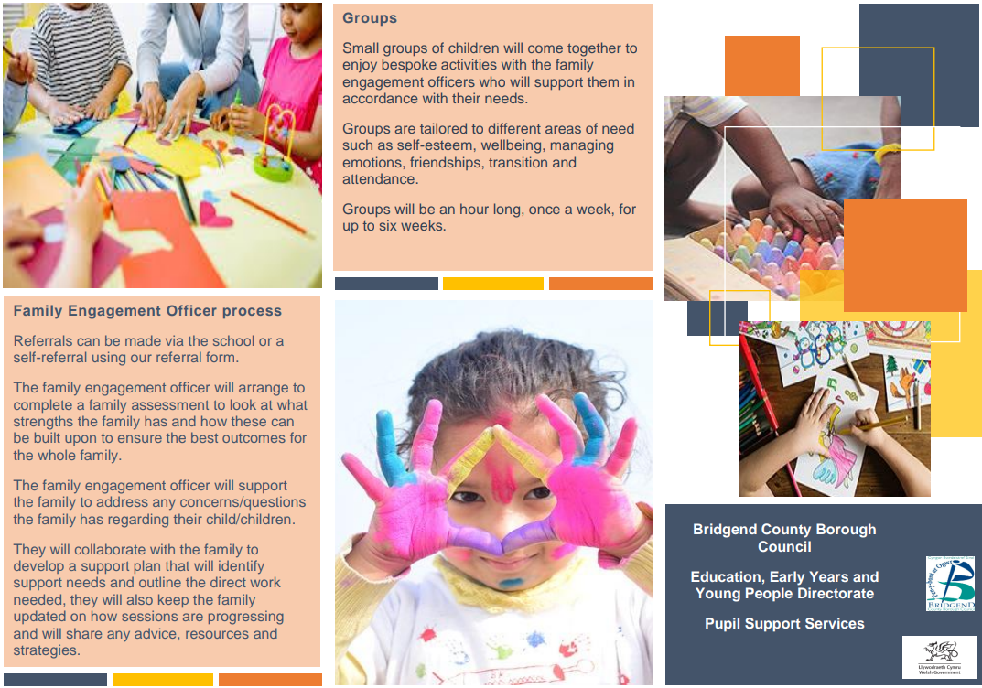
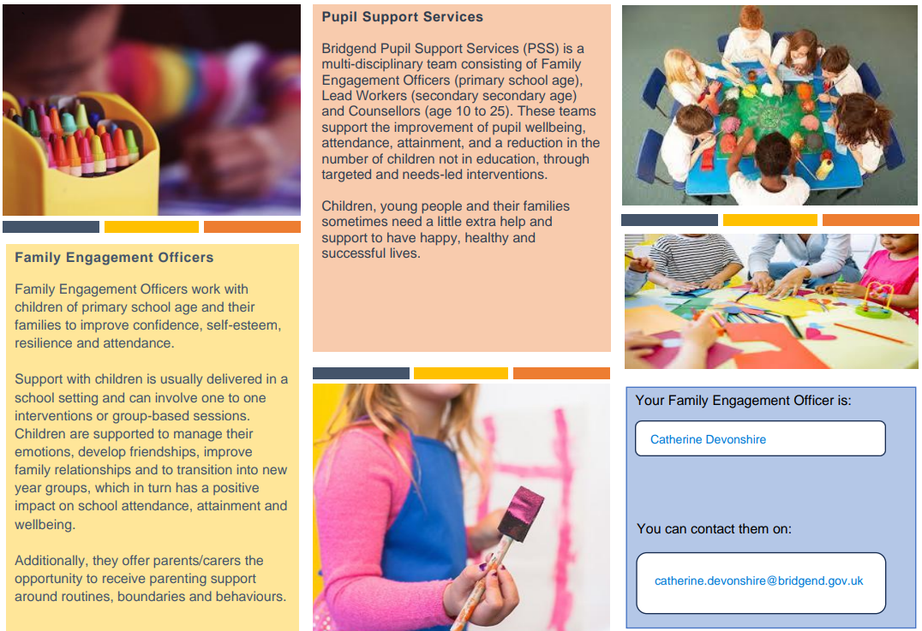
If you have any questions or require further information about any of the contents of this newsletter, don’t hesitate to contact us at: Admin.trelalesps@bridgened.cymru / 01656815611

