Welcome to the tenth edition of our newsletter. The Multiply Maths Parents session was a success. A huge thank you to everyone who gave up their time to attend. We also had a successful First Aid Course the following week. The children’s homework hub will now continue on a Thursday with the children of the original parents who attended the Multiply Session. We currently have room for a few more children. If you are interested please email or call the school and we can try to accommodate.
Issue 10
21st February 2025
If you have good thoughts they will shine out of your face like sunbeams and you will always look lovely.
Roald Dahl
Trelales Primary School Newsletter
Ysgol Gynradd Trelales

Shine Bright and Be your Brilliant Best!

The BIG news to tell you is that our New Kitchen will begin construction this weekend!!! There is a 20 week construction plan in place and we will keep you up to date with progress and any information regarding any changes to morning or afternoon access arrangements (none are expected).

After Half Term I will be looking at contacting those of you who have offered support to the school. We have so many projects in the pipeline as well as roles within the school which we could have support with.
We will shortly be putting out an invitation for 2 new Parent Governors so look out for an email after the half term with all the information you need.

All that leaves me to say is thank you so much for the support you give the school and I hope you have a lovely half term holiday.

Mr Gibson


School Calendar – Dates for your Diary
Thursday 13th Feb - Thursday 10th April - Numeracy Homework fun and games
Monday 24th - Friday 28th February - Half Term
Thursday 27th February - Multiply Festival - Archbishop McGrath School
Tuesday 4th March - Friends of Trelales Meeting 6pm @ The Mackworth Arms
Friday 7th March - School Eisteddfod
Monday 10th - Friday 14th March - STEM Week
Monday 24th - Wednesday 26th March - Parent’s Evenings
Friday 4th April - Year 6 to Crucial Crew
Friday 11th April - Last day of Spring Term
Monday 7th - Wednesday 9th July - Year 6 Residential to Llangrannog.


World Book Day
Due to World Book Day happening in the middle of our Welsh Week and the day before our Eisteddfod, we are postponing our celebrations until a day in the summer Term. We want to make sure the day is a real celebration of books and reading and don’t want it to be lost in our preparations for our Eisteddfod. This day will be a Storytelling Trial throughout the school and local park. We are asking if any parents or members of the community are interested in becoming a storyteller for the day. Contact the school for more information. FOTs will also be holding a book sale on 6th March to mark the day - 20p a book in the school hall.
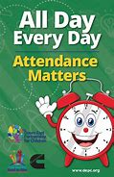
Attendance - Whole School Target 95%
This week’s whole school attendance is 95.6% with Year 2 in first place with 100% attendance. Llongyfarchiadau bawb. Year 1 are also the new half termly attendance champions. The whole school attendance for the half term is 94.6% which is really close to our 95% target. Well done to everyone for such good attendance.
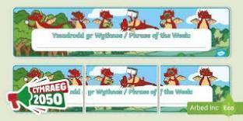
Welsh Phrase of the Week
In order to work towards our Bronze Award for the Siarter Iaith we are introducing the phrase of the week. Help your child by practising this at home.

W/B 3/3/25 - Dydd Gwyl Dewi Hapus! Happy Saint David’s Day
W/B 10/3/25 - Pawb yn Barod? – Everybody ready?

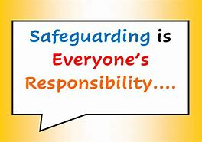
Safeguarding
Children’s welfare and wellbeing is at the heart of everything we do at Trelales.
Every person who works in the school has to have a DBS certificate and has annual training. The school’s safeguarding lead is Mr Gibson and deputy lead is Mrs Fitzgerald. If you have any concerns please raise them with a member of staff.
If you have concerns out in the community you can call MASH (Multi Agency Safeguarding Hub) on 01656 6422320. Alternatively, you can use this link to the website: Safeguarding
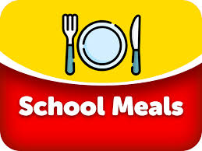
School Meals
As I am sure you are aware, School meals are free for pupils in Wales. We will be on Week 2 of the menu when we return after Half Term. You can find the menu on the school website.

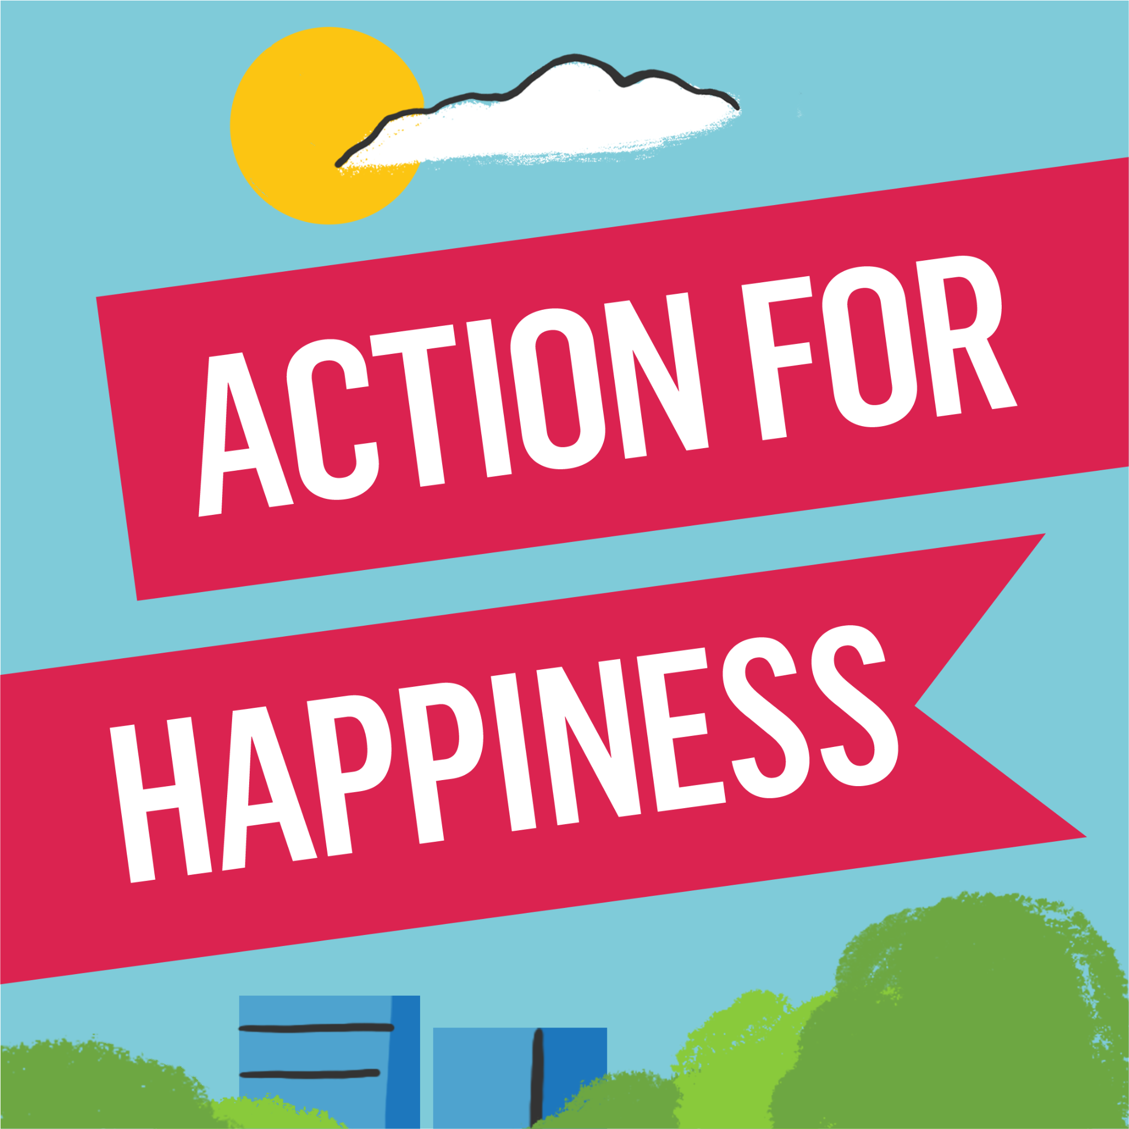
Action for Happiness
Every month the children look at one of the 10 keys to happiness which are 10 ways of being which can help us to be happy. The actions and mindsets themselves release positive chemicals in our brains and body called oxytocin, endorphins, serotonin and dopamine amongst others. We learn about these in assembly and then try to practise them through the month. Next month’s Action is Direction
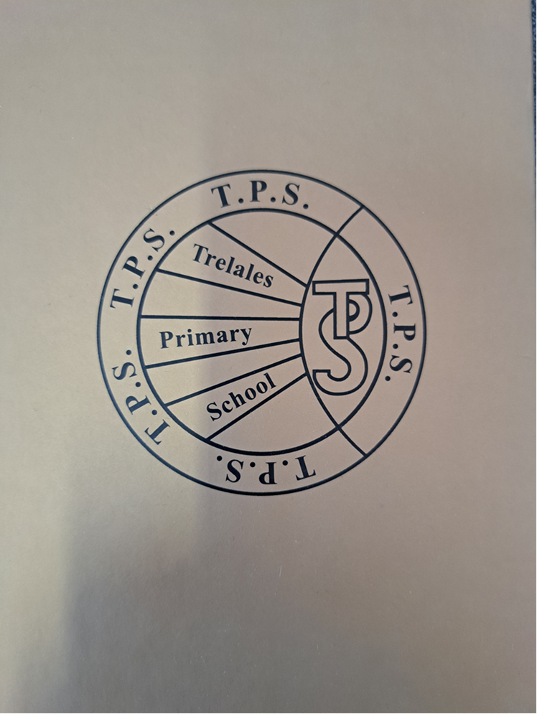
Value of the Month - The Golden Book
Similarly, we have a value of the month. There are eleven Trelales Values which the children decided upon at the beginning of the school year. We focus on one a month as well. Again, we discuss it in assembly and then build it into the month’s learning activities and celebrate the children practicing these values. At the end of every half term, one person is chosen from each class to be entered into the Golden Book, this child is someone who has demonstrated these values over and over again. The Values focused on this half term are Positivity and Gratitude.
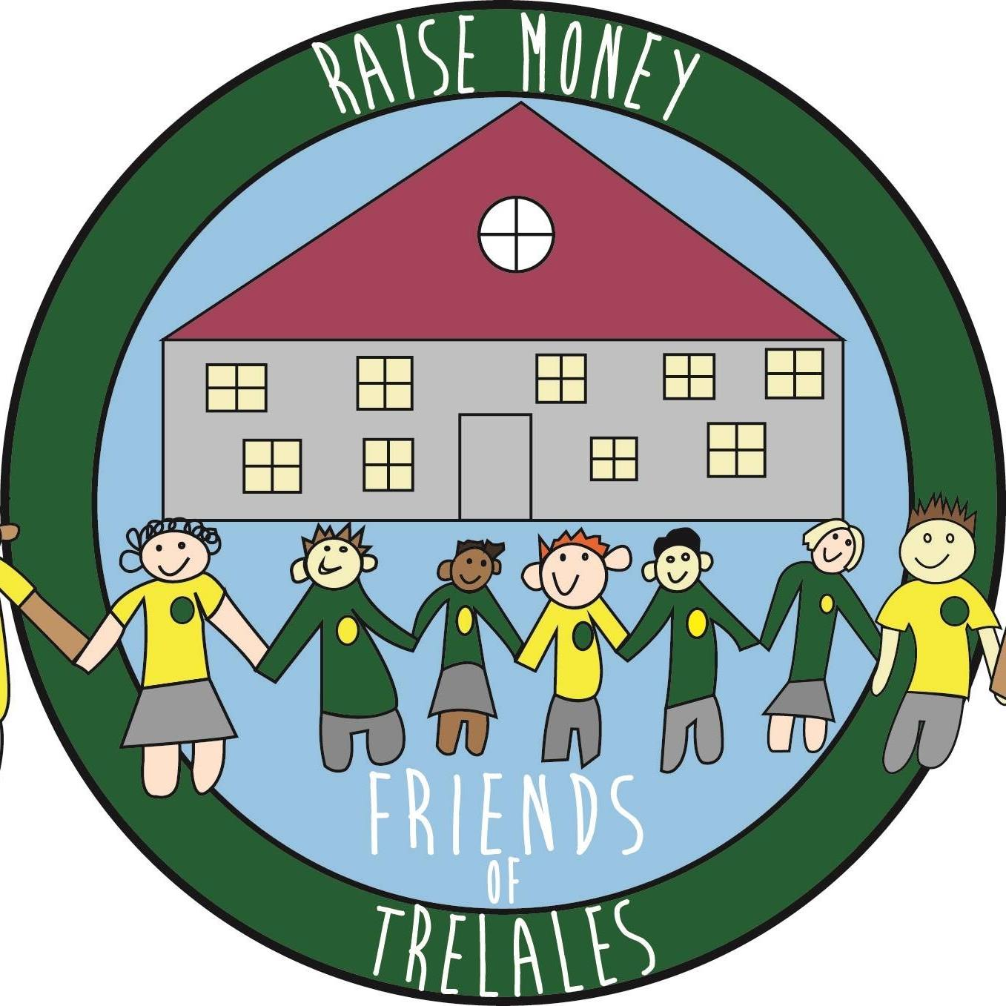
Friends of Trelales
We would like to thank everyone for such a successful Valentine’s Day pop up shop. We hope you and the children enjoyed the gifts available.
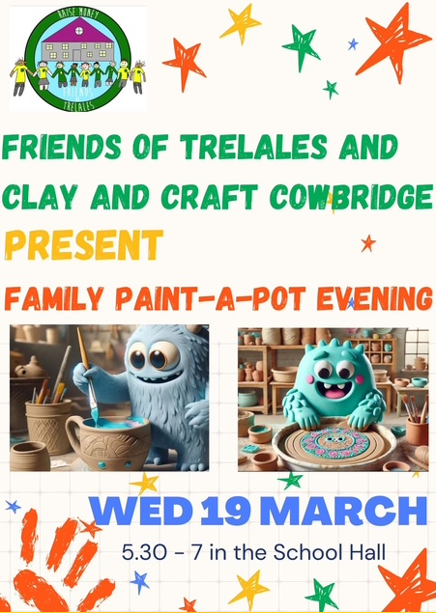
We have our very first ‘yes day’ - we hope that the children have enjoyed partaking in the preparation and also the day. A lovely fun way to end a busy half term. Thank you for supporting this event.
Coming up next term, when springtime finally arrives, we have lots of fun things for you to enjoy whilst you also help us to raise money for our fabulous children and school:
WORLD BOOK DAY SALE - 3pm on 6 March 2025. Please come along to purchase some pre loved books at very reasonable prices. It is also a chance to donate some of your pre loved books which can continue to be enjoyed by other children. Please leave good conditioned books at reception on and before 4 March 2025.
FAMILY PAINT A POT EVENING - collaboration with Clay and Craft Cowbridge.
19 March 2025, 5.30-7pm in the school hall. Come along and paint some fabulously cute pottery (including Easter theme) and make lovely memories together. £15 per ticket/painter with snacks and drinks available to buy on the evening.
Email - friendsoftrelales@hotmail.com . Let’s make this lovely event happen :)
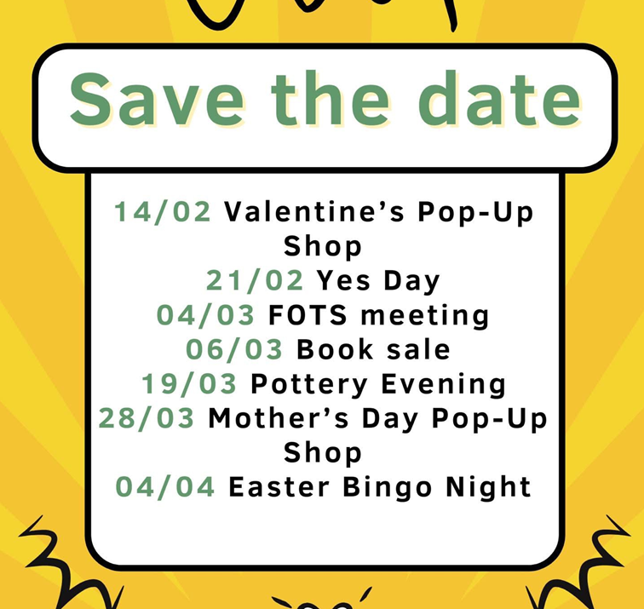
MOTHERS DAY POP UP SHOP - 28 March 2025. More great gifts will be available for those amazing people in the children’s life.
EASTER BINGO EVENING - 4 April 2025 - more info will follow but it will be full of fun, laughter and activities.

Thank you for continuing to support us. We hope you and the children have fun whilst you do so. Have a lovely half term.

Family Engagement officer and Early Help.
Early Years and Young People Support Services
Bridgend County Borough Council has a service for families and organisations to refer to if they feel they need support with a range of concerns. The following link will take you to the webpage for further information. Our school has a family engagement officer who visits once a week, her contact details are on the flyer.
Bridgend Early Help Services - Bridgend CBC
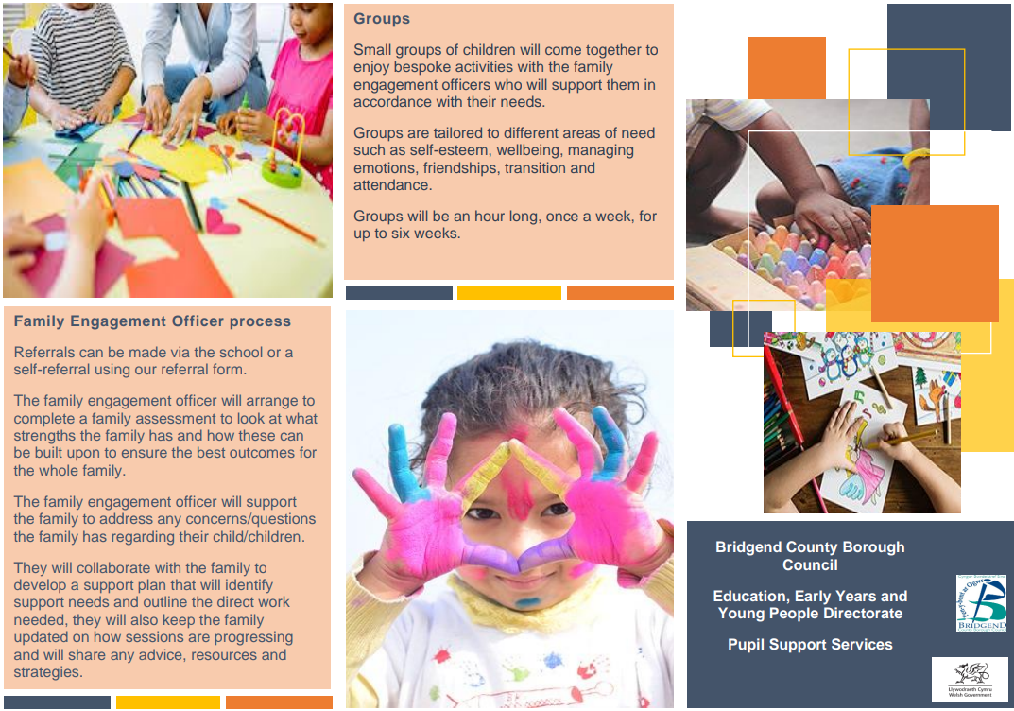
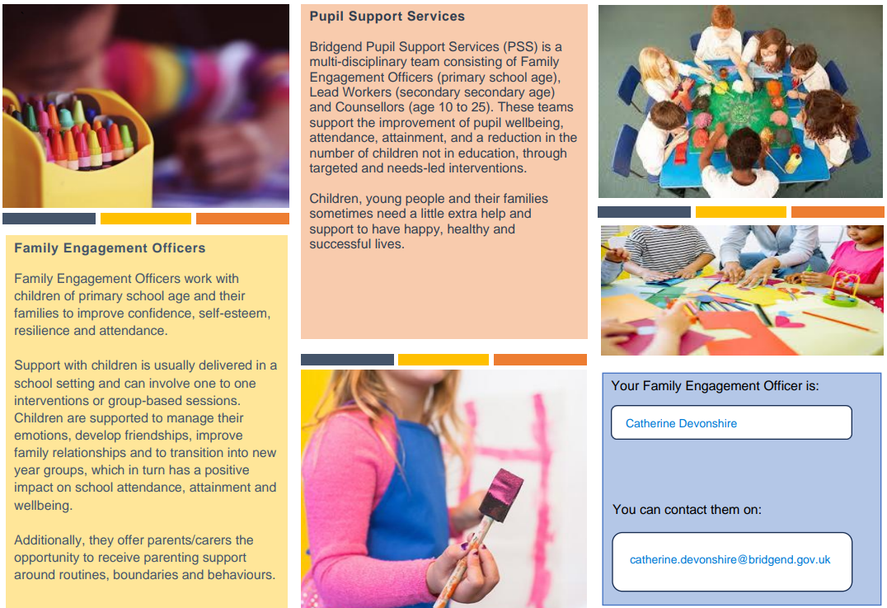
If you have any questions or require further information about any of the contents of this newsletter, don’t hesitate to contact us at: Admin.trelalesps@bridgened.cymru / 01656815611

