Welcome to the eleventh edition of our newsletter.
Issue 11
14th March 2025
The body heals with play, the mind heals with laughter and the spirit heals with joy
Proverb
Trelales Primary School Newsletter
Ysgol Gynradd Trelales

Shine Bright and Be your Brilliant Best!
Our New Kitchen has begun construction. We are almost three weeks into the project and although they have found a few things that shouldn’t have been there such as old pipes and cables from previous buildings, progress is looking good. As you know, there is a 20 week construction plan in place and the plan is to hand the new kitchen over in July.

We have had a fun start to this half term. Welsh week saw lots of wonderful Welsh themed buddy class activities and culminated in a wonderful day of Welsh Celebration on our Eisteddfod. Matilda was crowned as the bard for this year and her poem was sensational.

This week we have been celebrating STEM week, with the children learning different science experiments linked to the theme Adapt and Change. This has culminated in a wonderful science fair on Friday afternoon where each class has set up an activity in the hall to demonstrate their learning.

We will be hosting another ‘Big Dig’ day, hopefully before Easter. As always, thank you for your support.

Mr Gibson


School Calendar – Dates for your Diary
Thursday 13th Feb - Thursday 10th April - Numeracy Homework fun and games
Monday 17th March - Team Wales athlete visiting Years 3-5
Wednesday 19th March - Pottery Night @ 5:30pm - see FOTs members for tickets
Friday 21st March - Red Nose Day - Wear Red, donate minimum £1
Monday 24th - Friday 4th April - Big Walk and Wheel to school fortnight
Monday 24th - Tuesday 25th March - Parent’s Evenings
Monday 24th - Governor's School Tour @ 9.15am
Tuesday 25th - Governor's School Tour @ 9.15am
Tuesday 25th March - Phil Cope to start Phase 2 of Laleston Well Project with Year 6
Thursday 27th March - Primary 5s football festival at Penybont Football club
Tuesday 1st April - Governing Body Meeting
Wednesday 2nd April - Well Project - Year 6 to visit local wells
Friday 4th April - Year 6 to Crucial Crew
Friday 11th April - Last day of Spring Term and Easter Bonnet parade
Monday 7th - Wednesday 9th July - Year 6 Residential to Llangrannog.
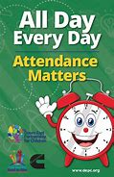
Attendance - Whole School Target 95%
This week’s whole school attendance is 95.4% with Year 3 in first place with 100% attendance. Llongyfarchiadau bawb! Our ongoing school attendance is 94%, we are slowly recovering from the ‘Laleston Virus’ that wiped us out in December!

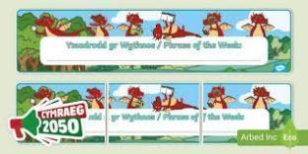
Welsh Phrase of the Week
In order to work towards our Bronze Award for the Siarter Iaith we are introducing the phrase of the week. Help your child by practising this at home.

W/B 17/3/25 - Beth wyt ti’n hoffi? Dw i’n hoffi… Dw i ddim yn hoffi

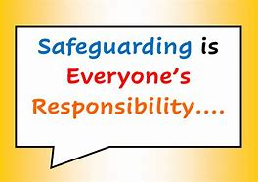
Safeguarding
Children’s welfare and wellbeing is at the heart of everything we do at Trelales.
Every person who works in the school has to have a DBS certificate and has annual training. The school’s safeguarding lead is Mr Gibson and deputy lead is Mrs Fitzgerald. If you have any concerns please raise them with a member of staff.
If you have concerns out in the community you can call MASH (Multi Agency Safeguarding Hub) on 01656 6422320. Alternatively, you can use this link to the website: Safeguarding
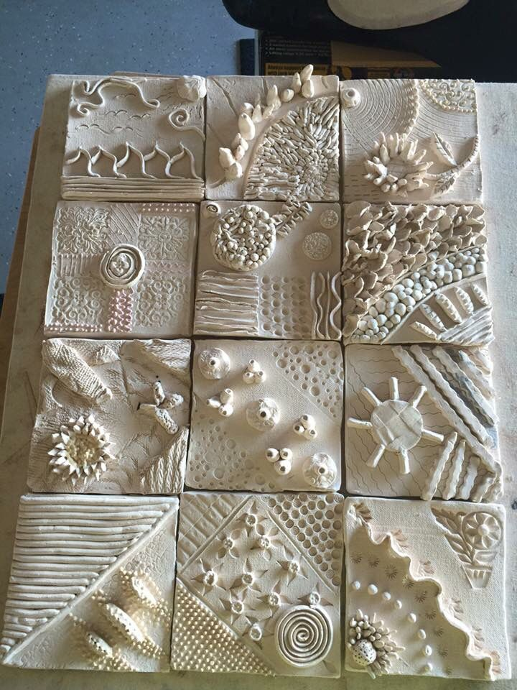

Pottery fun and a new Foyer!
Next week we are so excited to start our new project to brighten up the school foyer. We are looking forward to working with a pottery artist for all the children to create a clay tile of what Trelales means to them. Each tile will then be placed on the wall in the foyer to build up a welcoming Mural. In order to cover the cost of the clay, please could we ask each child to bring in £3.
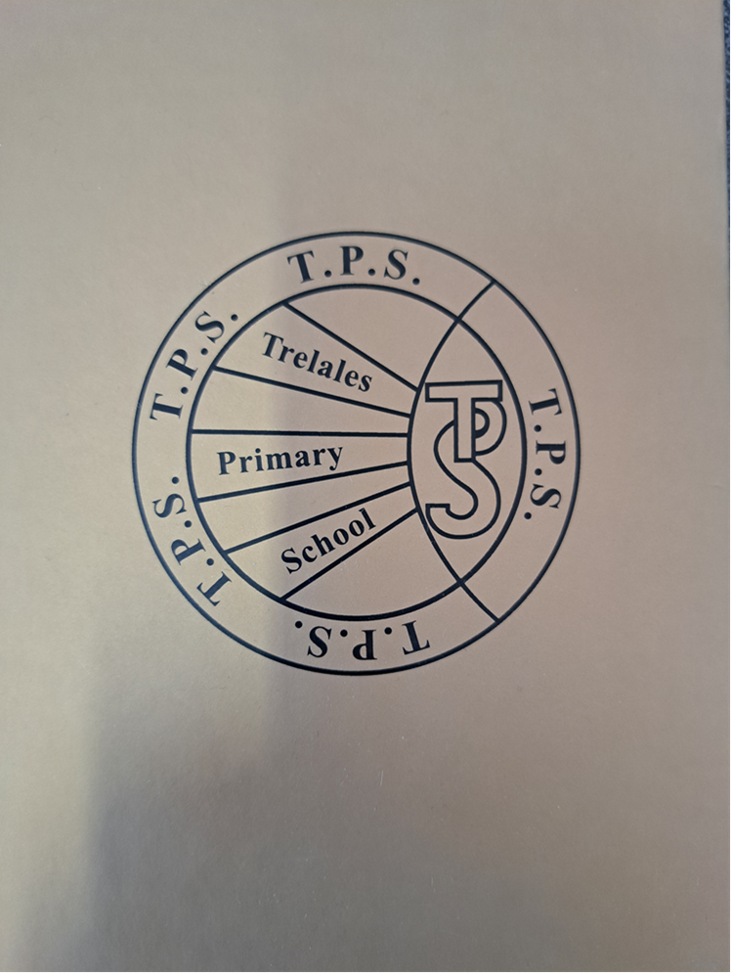
Value of the Month - The Golden Book
Similarly, we have a value of the month. There are eleven Trelales Values which the children decided upon at the beginning of the school year. We focus on one a month as well. Again, we discuss it in assembly and then build it into the month’s learning activities and celebrate the children practicing these values. At the end of every half term, one person is chosen from each class to be entered into the Golden Book, this child is someone who has demonstrated these values over and over again. The Values focused on this half term are Happiness and Forgiveness.

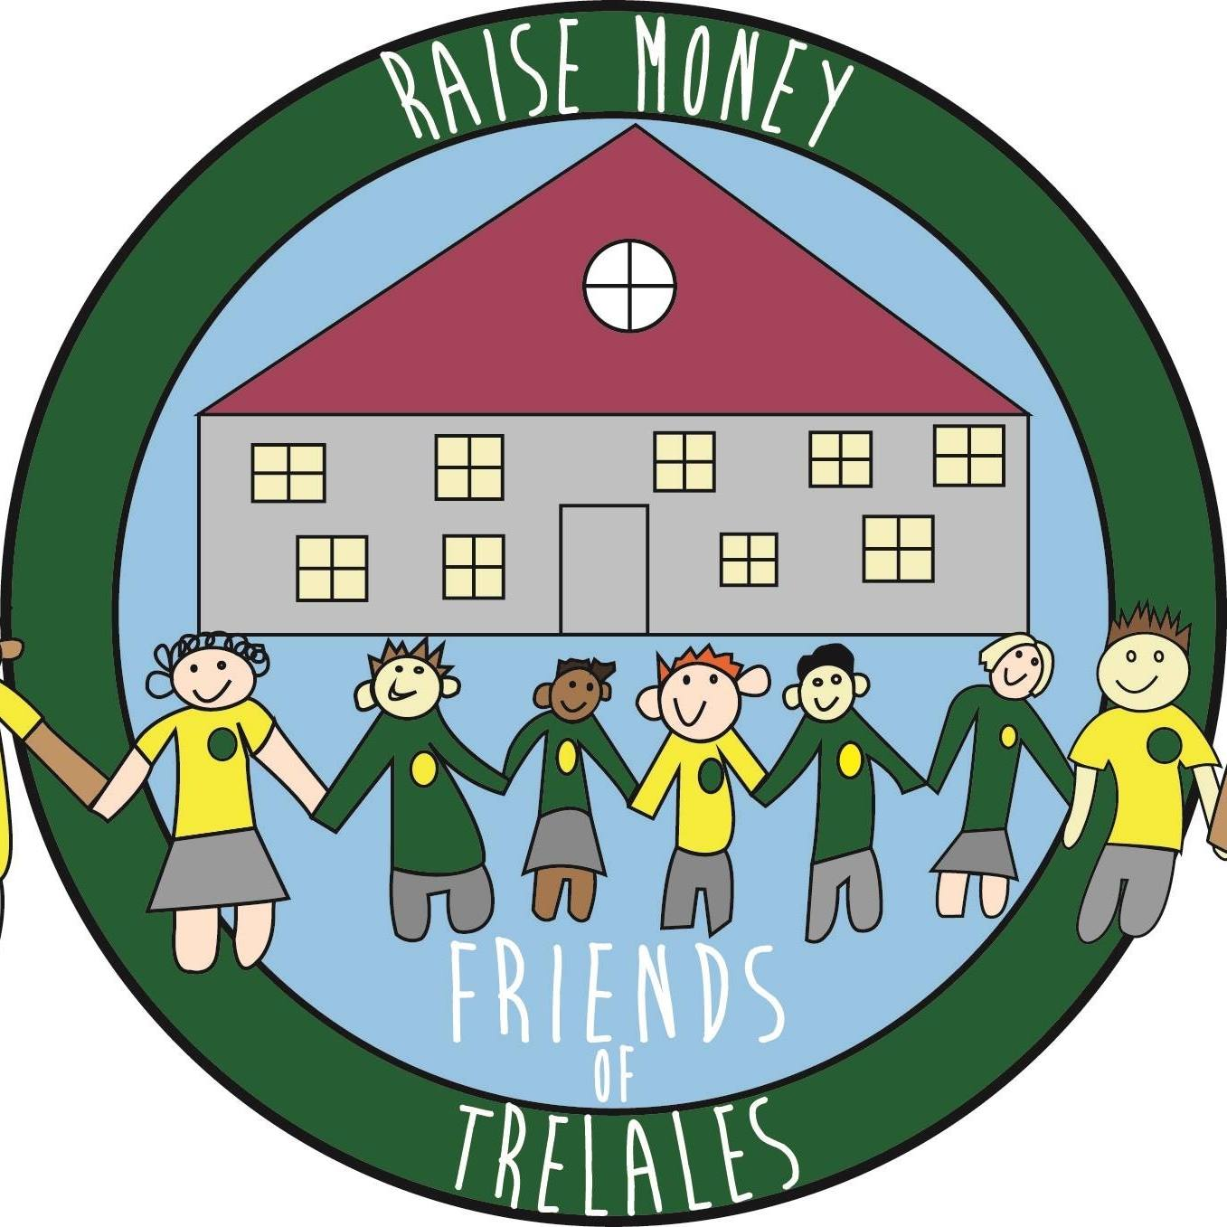
Friends of Trelales
Coming up this term, when springtime finally arrives, we have lots of fun things for you to enjoy whilst you also help us to raise money for our fabulous children and school:
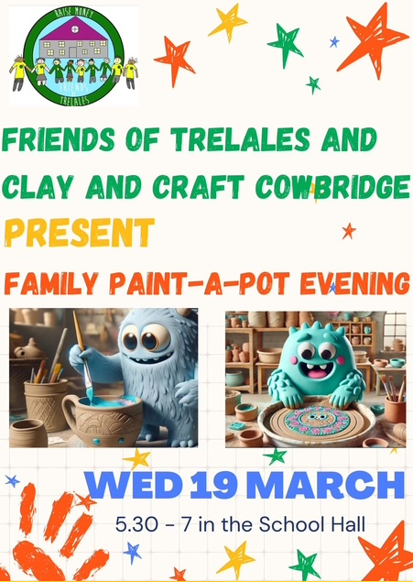
FAMILY PAINT A POT EVENING - collaboration with Clay and Craft Cowbridge.
19 March 2025, 5.30-7pm in the school hall. Come along and paint some fabulously cute pottery (including Easter theme) and make lovely memories together. £15 per ticket/painter with snacks and drinks available to buy on the evening.
Email - friendsoftrelales@hotmail.com . Let’s make this lovely event happen :)
MOTHERS DAY POP UP SHOP - 28 March 2025. More great gifts will be available for those amazing people in the children’s life. Thank you for continuing to support us. We hope you and the children have fun whilst you do so.
Family Engagement officer and Early Help.
Early Years and Young People Support Services
Bridgend County Borough Council has a service for families and organisations to refer to if they feel they need support with a range of concerns. The following link will take you to the webpage for further information. Our school has a family engagement officer who visits once a week, her contact details are on the flyer.
Bridgend Early Help Services - Bridgend CBC
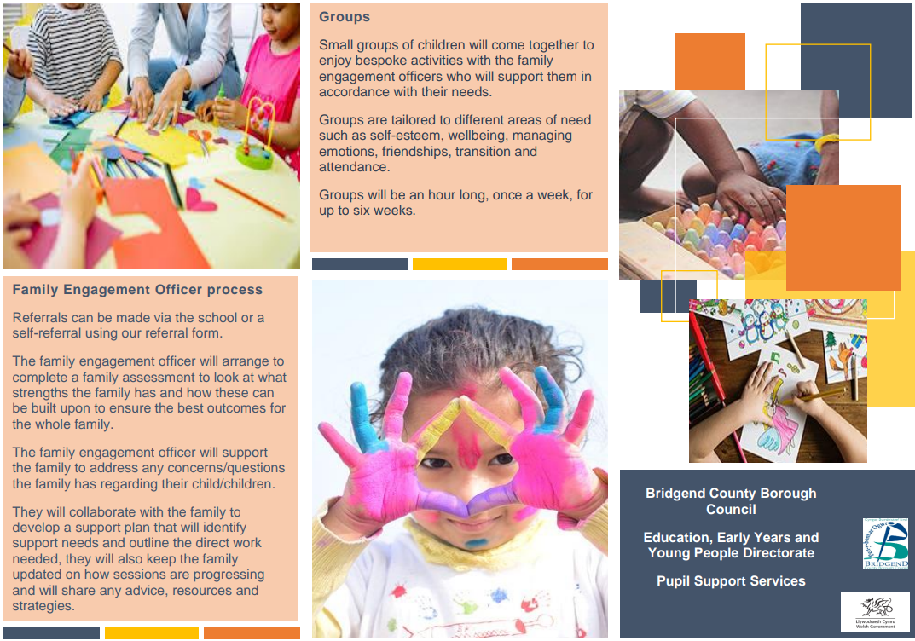
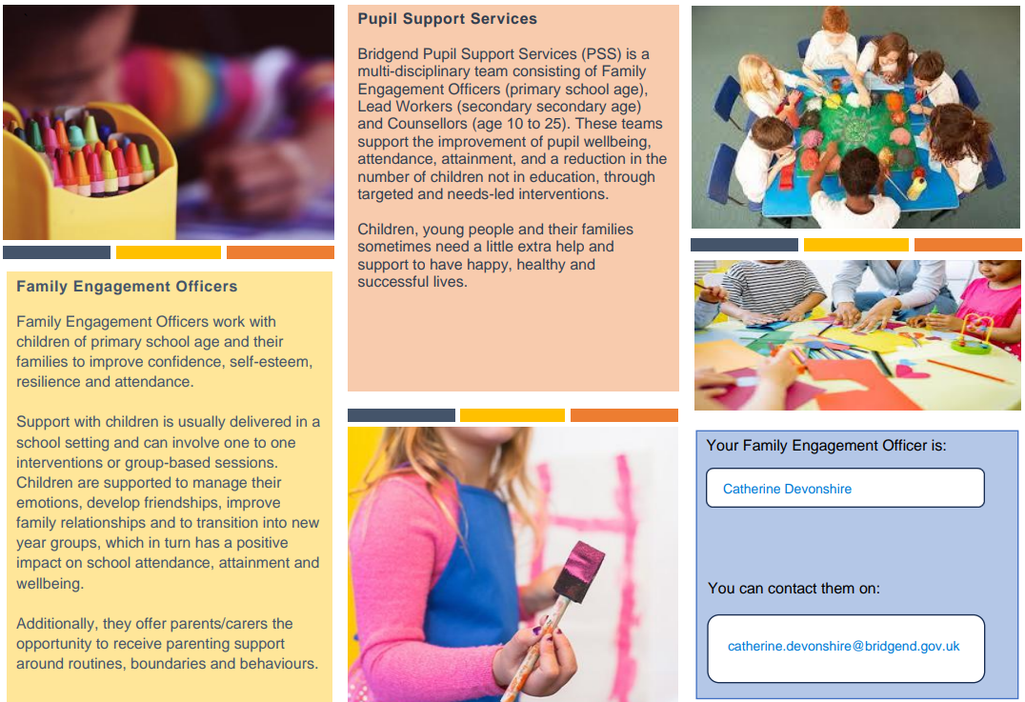
If you have any questions or require further information about any of the contents of this newsletter, don’t hesitate to contact us at: Admin.trelalesps@bridgened.cymru / 01656815611

