Welcome to the twelfth edition of our newsletter.
Issue 12
28th March 2025
Change will not come if we wait for some other person or some other time. We are the ones we’ve been waiting for.
Barack Obama
Trelales Primary School Newsletter
Ysgol Gynradd Trelales

Shine Bright and Be your Brilliant Best!
Our New Kitchen is beginning to take shape. The children are enjoying watching the development happen. If you have any questions regarding the build and implications, please feel free to contact the school.

We have had a range of fun and different experiences for the children over the past fortnight. From visits from Team Wales and ADA Recycling to Phil Cope beginning work on the Well development projects! We also had our Governing Body visits. Our head and deputy head pupils showed them around and discussed all our plans for the future.

We also had two very successful Parent’s Evenings. Thank you so much for supporting these events. They are always long nights but a real celebration of the children’s learning. A huge thank you to the teachers for the effort and commitment they give to these events.

The school would like to say a huge thank you to Mr Dring who has started on a pottery project with all the children in the school. The children in Year 3 -6 have created tiles to depict what Trelales means to them. The rest of the school will be completing theirs over the next 2 weeks. These tiles will be going up on the walls in the school foyer. We can’t wait to see what the finished project will look like.

The school sports teams have been busy over the last few weeks. Congratulations to all our Cross Country runners and to the School’s football teams who both got to the quarter finals of the Primary 5s tournament yesterday only to be defeated on a penalty shoot out.

We will be hosting another ‘Big Dig’ on Saturday 5th April. The day will begin at 10am. We need to clear the debris from the nature area to be able to clear a space to start work on an outdoor classroom. Please can you let the school know if you intend to come along, it should only be a couple of hours work this time!!

Mr Gibson


School Calendar – Dates for your Diary
Tuesday 1st April - Governing Body Meeting
Wednesday 2nd April - Well Project - Year 6 to visit local wells
Friday 4th April - Year 6 to Crucial Crew
Friday 11th April - Last day of Spring Term and Easter Bonnet parade
Tuesday 29th - Fire safety talk Year 2 and 5
Friday 2nd May - Mini Olympics @ Bryntirion for Yr 6
Monday 5th May - Bank Holiday
Wednesday 7th May - Rugby Tournament - Dunraven Bay Year 5 and 6
Thursday 8th May - Paul Leyshon - author visit for Year 4, 5 and 6.
Wednesday 14th May - Apollo Football Tournament
Tuesday 6th - Fri 23rd May - Online Personalised Assessments for Year 2 - 6
Monday 26th - 30th May - Half Term
Monday 9nd June - INSET day - school closed to pupils
Friday 4th July - Reports Out
Monday 7th - Wednesday 9th July - Year 6 Residential to Llangrannog.
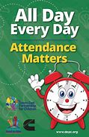
Attendance - Whole School Target 95%
This week’s whole school attendance is 94.7% with Year 2 in first place with 100% attendance. Llongyfarchiadau bawb! Our ongoing school attendance is 94.1%, we are slowly recovering from the ‘Laleston Virus’ that wiped us out in December!

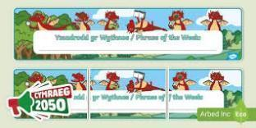
Welsh Phrase of the Week
In order to work towards our Bronze Award for the Siarter Iaith we are introducing the phrase of the week. Help your child by practising this at home.

W/B 31/3/25 - Faint o gloch ydy hi? What time is it?
W/B 7/4/25 - Ga i helpu? Can I help you?

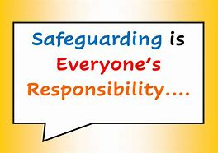
Safeguarding
Children’s welfare and wellbeing is at the heart of everything we do at Trelales.
Every person who works in the school has to have a DBS certificate and has annual training. The school’s safeguarding lead is Mr Gibson and deputy lead is Mrs Fitzgerald. If you have any concerns please raise them with a member of staff.
If you have concerns out in the community you can call MASH (Multi Agency Safeguarding Hub) on 01656 6422320. Alternatively, you can use this link to the website: Safeguarding
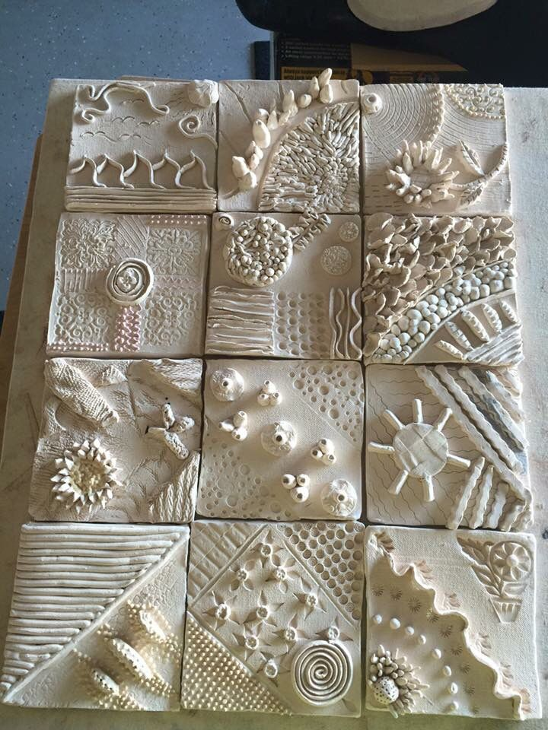

Pottery fun and a new Foyer!
Next week we are so excited to start our new project to brighten up the school foyer. We are looking forward to working with a pottery artist for all the children to create a clay tile of what Trelales means to them. Each tile will then be placed on the wall in the foyer to build up a welcoming Mural. In order to cover the cost of the clay, please could we ask each child to bring in £3.

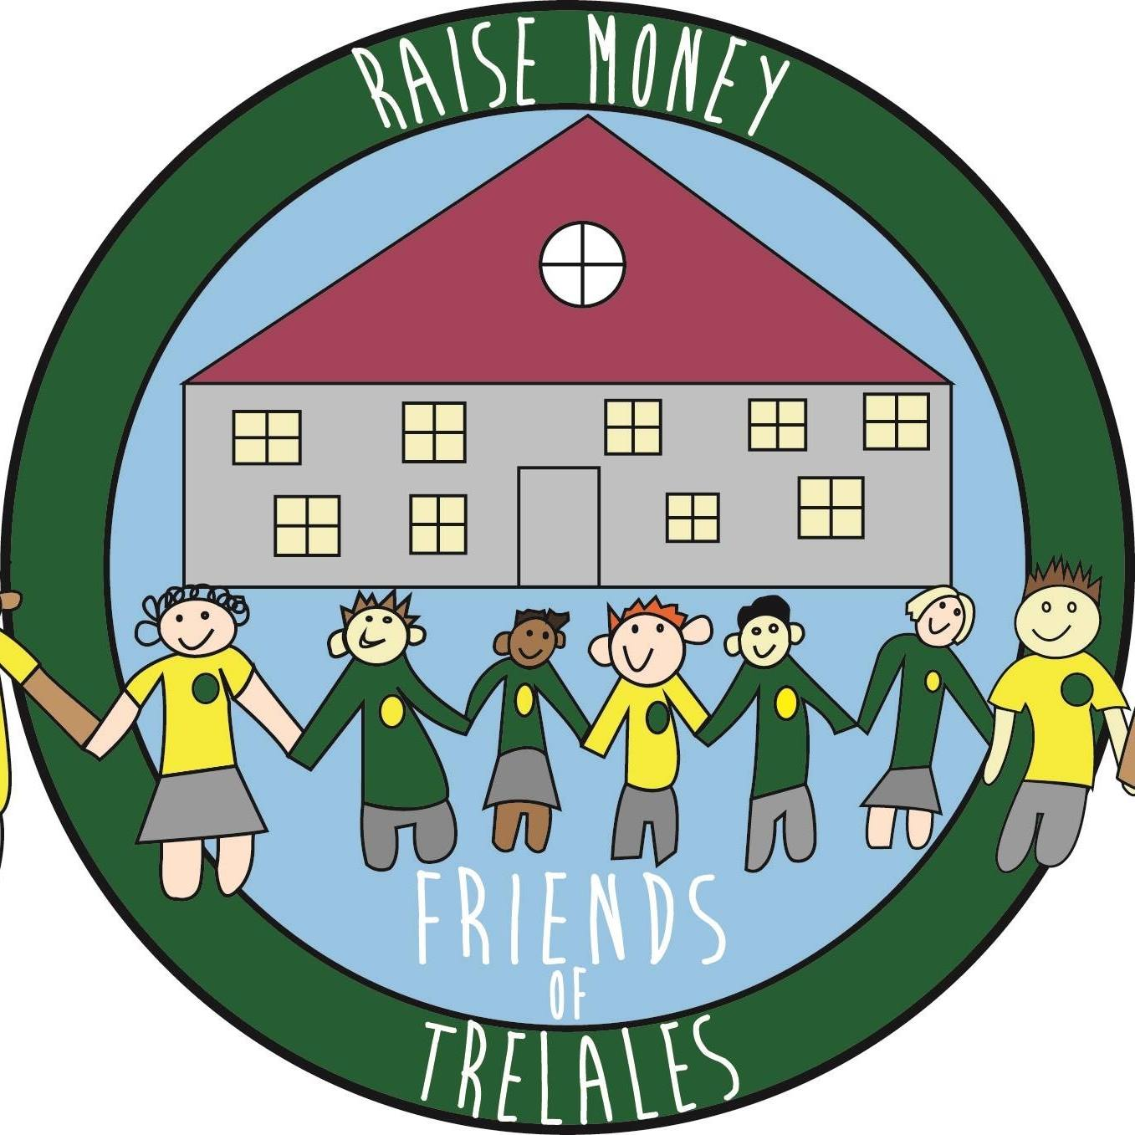
Friends of Trelales
Coming up this term, when springtime finally arrives, we have lots of fun things for you to enjoy whilst you also help us to raise money for our fabulous children and school:
MOTHERS DAY POP UP SHOP - 28 March 2025. More great gifts will be available for those amazing people in the children’s life. Thank you for continuing to support us. We hope you and the children have fun whilst you do so.
Family Engagement officer and Early Help.
Early Years and Young People Support Services
Bridgend County Borough Council has a service for families and organisations to refer to if they feel they need support with a range of concerns. The following link will take you to the webpage for further information. Our school has a family engagement officer who visits once a week, her contact details are on the flyer.
Bridgend Early Help Services - Bridgend CBC
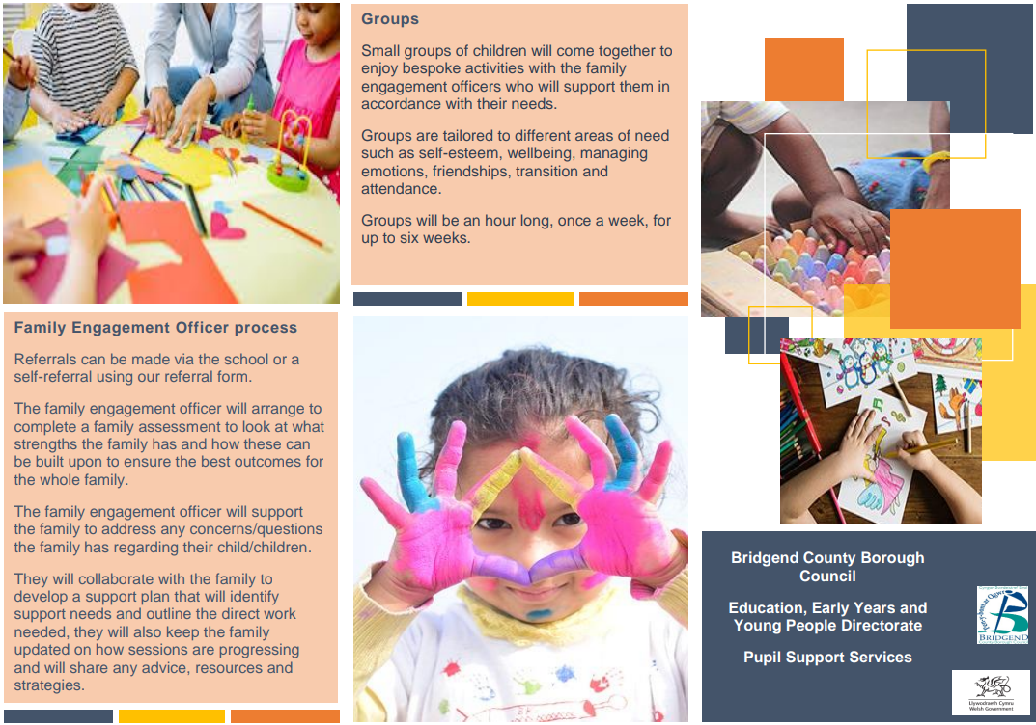
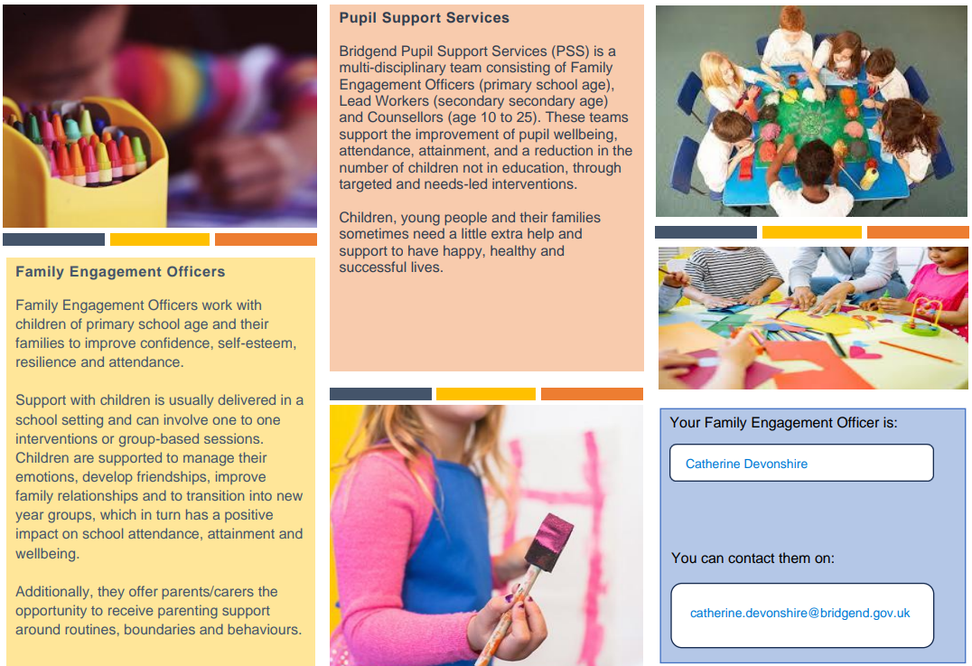
If you have any questions or require further information about any of the contents of this newsletter, don’t hesitate to contact us at: Admin.trelalesps@bridgened.cymru / 01656815611

