Welcome to the thirteenth edition of our newsletter.
Issue 13
11th April 2025
One positive thought in the morning can change your whole day.

Trelales Primary School Newsletter
Ysgol Gynradd Trelales

Shine Bright and Be your Brilliant Best!
I can’t believe we are at the end of the Spring Term! The children have been working so hard and have been creating some wonderful and varied pieces of learning.

We have had a range of fun and different experiences for the children over the past fortnight. Phil Cope took Year 6 on a really informative and surprising tour of local wells, you would be amazed at how many you pass each day! They have also been on their Crucial Crew visit. Year 3 had a great visit to the Museum and spoiled their parents to a wonderful fashion show and sing song. Mr Dring has now worked with all classes to create tiles for the main entrance, we cannot wait to see what it looks like when they are put up. We have had visits from our Improvement Partner and a Governing Body meeting. Look out for an email regarding future Parent Governor vacancies.

Our school choir and guitar band, ‘Miscellaneous’ represented Trelales at the Gamanfa Ganu at St Mary’s Church in Nolton, which was a beautiful celebration of singing and Welsh. A huge thank you to Mr Phillips for helping the choir to learn the songs. A special mention to Miscellaneous who were the only ‘solo’ act to perform.

Thank you again to the parents who came and helped clear the nature area on Saturday. It is looking great and is ready for the next phase of the redevelopment.

We have welcomed several new children into the school over the last few weeks, and since September we have increased our numbers by 15 with another 4 set to join after Easter. This is fantastic news and testament to the nurturing environment and amazing learning experiences we are giving our children. Keep spreading the word so we can continue to grow our school community.

Mr Gibson


School Calendar – Dates for your Diary
Tuesday 29th April - Fire safety talk Year 2 and 5
Friday 2nd May - Mini Olympics @ Bryntirion for Yr 6
Monday 5th May - Bank Holiday
Wednesday 7th May - Rugby Tournament - Dunraven Bay Year 5 and 6
Thursday 8th May - Paul Leyshon - author visit for Year 4, 5 and 6.
Wednesday 14th May - Apollo Football Tournament
Tuesday 6th - Fri 23rd May - Online Personalised Assessments for Year 2 - 6
Monday 26th - 30th May - Half Term
Monday 9nd June - INSET day - school closed to pupils
Friday 4th July - Reports Out
Monday 7th - Wednesday 9th July - Year 6 Residential to Llangrannog.
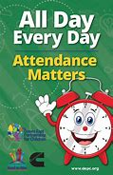
Attendance - Whole School Target 95%
This week’s whole school attendance is 95.1% with Year 3 in first place with 99.1% attendance. Llongyfarchiadau bawb! The half termly winners were Year 2 with 97.8%. They just pipped Year 1 who had 97.7%!! Our ongoing school attendance is 94.2%, we are slowly recovering from the ‘Laleston Virus’ that wiped us out in December!

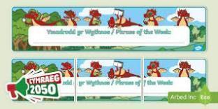
Welsh Phrase of the Week
In order to work towards our Bronze Award for the Siarter Iaith we are introducing the phrase of the week. Help your child by practising this at home.

W/B 28/04/25 - Wyt ti’n Barod? Ydw / Nag Ydw - Are you ready? Yes / No
W/B 05/05/25 - Beth sy’n bod? Mae ______ tost gyda fi. What’s the matter? My ___ is hurting.

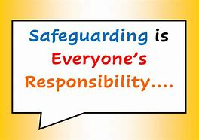
Safeguarding
Children’s welfare and wellbeing is at the heart of everything we do at Trelales.
Every person who works in the school has to have a DBS certificate and has annual training. The school’s safeguarding lead is Mr Gibson and deputy lead is Mrs Fitzgerald. If you have any concerns please raise them with a member of staff.
If you have concerns out in the community you can call MASH (Multi Agency Safeguarding Hub) on 01656 6422320. Alternatively, you can use this link to the website: Safeguarding

Photographing / filming children
Please can we remind all parents that if you want to take a photo / film of your child during school shows and events that it is only for your own personal viewing. It cannot be placed on any social media sites, particularly as other children may be in the photo / film.

Family Engagement officer and Early Help.
Early Years and Young People Support Services
Bridgend County Borough Council has a service for families and organisations to refer to if they feel they need support with a range of concerns. The following link will take you to the webpage for further information. Our school has a family engagement officer who visits once a week, her contact details are on the flyer.
Bridgend Early Help Services - Bridgend CBC
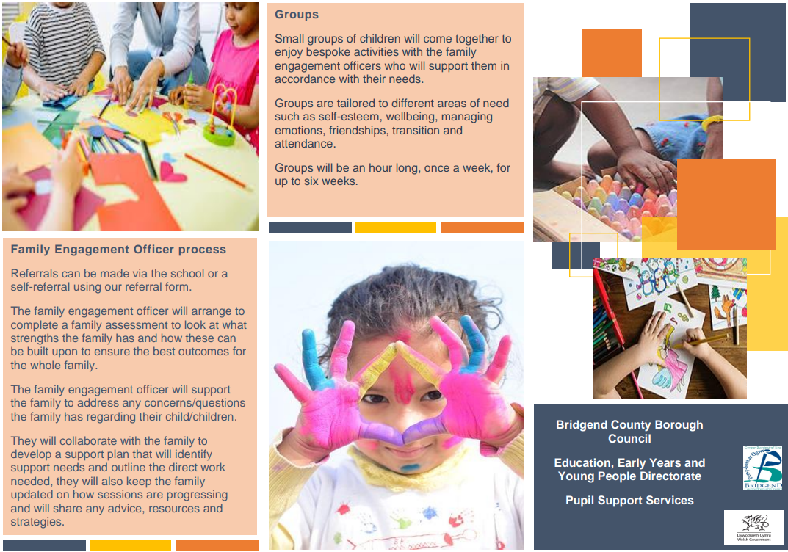
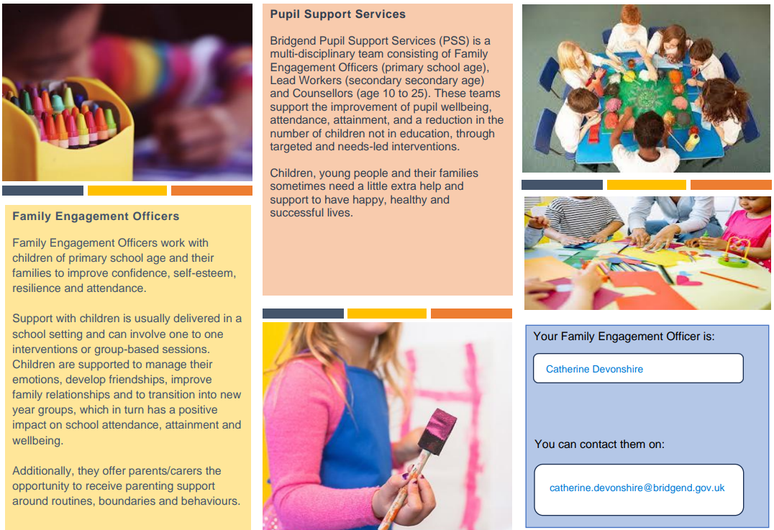
If you have any questions or require further information about any of the contents of this newsletter, don’t hesitate to contact us at: Admin.trelalesps@bridgened.cymru / 01656815611

