Welcome to the fourteenth edition of our newsletter.
Issue 14
9th May 2025
Ordinary me can achieve SOMETHING EXTRAORDINARY, by giving that little bit extra.
Bear Grylls

Trelales Primary School Newsletter
Ysgol Gynradd Trelales

Shine Bright and Be your Brilliant Best!
Half way through the half term already!! And what a bust start.
Year 2 and 5 welcomed the Fire Service into school where they talked about fire safety and explored the fire engine. Year 6 had a great mini olympics event at Bryntirion Comprehensive as part of their transition events. The children represented Trelales impeccably and were complimented on their behaviour by all who met them.
Mr Perkins took the school to the Rugby Tournament this week and the children played their hardest but got knocked out in the group stages. On to the football tournament next week!
Year 3, 4, 5 and 6 had a visit from author P.D. Leyshon, he read from his new book and gave workshops on creative writing.

This year to celebrate World Book Day (which is Trelales Book Day), we would like to arrange a story trail around the school site and into the park and woods surrounding the school. We plan to do this on Friday 20th June. For this to work, we need parents (or family members) to offer to be the storytellers for the day. The children will move around the storytellers and spend approximately 20 mins with each story teller. Our storytellers need to have a selection of stories (for different age groups) and these can be read / told / acted out for the children at each place. If you are interested in being one of Trelales’ first ever story tellers please contact the school to let us know. We need 8 in total so we can have each class accommodated for.

Another date for the diary is Sports day, as with previous years we will plan to do this on the first dry day in the week beginning 23rd June. More information will follow regarding the set up for the day.

The children from Year 2 - 6 have started doing their Online Personalised Assessments, they are scheduled to be completed before half term. The reports will then be released to parents via the pupils’ hwb email.

A huge thank you to Laura Morris and Elizabeth Payne who have both been successful in achieving grants for the school. Exciting opportunities for outdoor learning!! Your support is invaluable.
Mr Gibson


School Calendar – Dates for your Diary
Wednesday 14th May - Apollo Football Tournament
Tuesday 6th - Fri 23rd May - Online Personalised Assessments for Year 2 - 6
Monday 26th - 30th May - Half Term
Monday 9nd June - INSET day - school closed to pupils
Friday 20th June - Trelales Story Trail
w/b Monday 23rd June - Sports day - first available dry day (hopefully Monday)
Thursday 3rd July - Leavers Assembly
Monday 7th July - Reports Out
Monday 7th - Wednesday 9th July - Year 6 Residential to Llangrannog.
Wednesday 16th July - Nursery Graduation
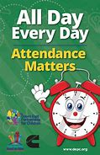
Attendance - Whole School Target 95%
This week’s whole school attendance is 94.5% with Year 1 in first place with 99.3% attendance. Llongyfarchiadau bawb! The half termly winners were Year 2 with 97.8%. They just pipped Year 1 who had 97.7%!! Our ongoing school attendance is 94.2%, we are slowly recovering from the ‘Laleston Virus’ that wiped us out in December!

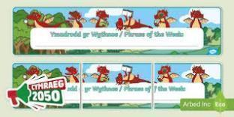
Welsh Phrase of the Week
In order to work towards our Bronze Award for the Siarter Iaith we are introducing the phrase of the week. Help your child by practising this at home.

W/B 12/05/25 - Gwisgwch eich het. Wear your hat.
W/B 19/05/25 - Mae hi’n boeth. It is warm

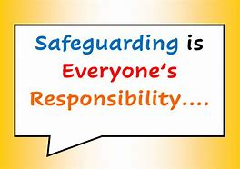
Safeguarding
Children’s welfare and wellbeing is at the heart of everything we do at Trelales.
Every person who works in the school has to have a DBS certificate and has annual training. The school’s safeguarding lead is Mr Gibson and deputy lead is Mrs Fitzgerald. If you have any concerns please raise them with a member of staff.
If you have concerns out in the community you can call MASH (Multi Agency Safeguarding Hub) on 01656 6422320. Alternatively, you can use this link to the website: Safeguarding

Photographing / filming children
Please can we remind all parents that if you want to take a photo / film of your child during school shows and events that it is only for your own personal viewing. It cannot be placed on any social media sites, particularly as other children may be in the photo / film.

Keep Wales Tidy Grant Success
Thanks to the amazing efforts of Laura Morris, the school has been accepted for a Keep Wales Tidy grant for gardening and growing equipment. In order to get the full grant we need a team of volunteers who will help with the creation of different growing areas and also the maintenance of these. Please contact the school if you are interested in helping out.

Family Engagement officer and Early Help.
Early Years and Young People Support Services
Bridgend County Borough Council has a service for families and organisations to refer to if they feel they need support with a range of concerns. The following link will take you to the webpage for further information. Our school has a family engagement officer who visits once a week, her contact details are on the flyer.
Bridgend Early Help Services - Bridgend CBC
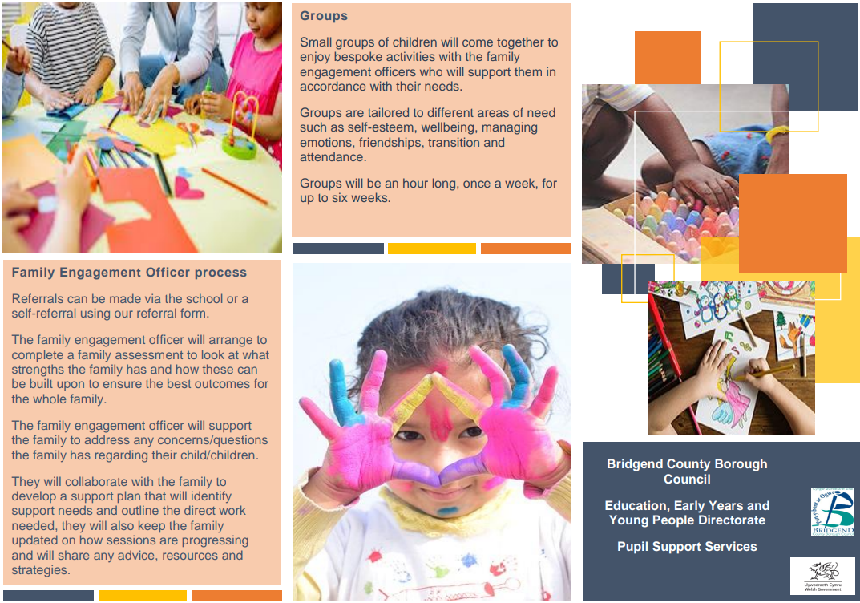
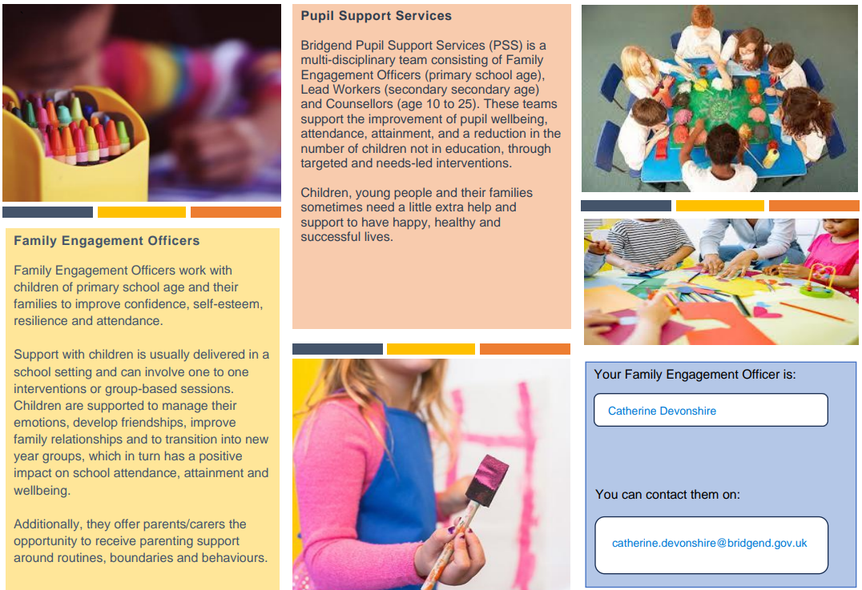
If you have any questions or require further information about any of the contents of this newsletter, don’t hesitate to contact us at: Admin.trelalesps@bridgened.cymru / 01656815611

