As we approach another half term (yes, already!) I wanted to update you on some exciting upcoming events. We were successful in our Keep Wales Tidy bid and are expecting our first delivery of materials on Tuesday 3rd June. We are hoping that some of you can volunteer on this day to help build the raised beds, please contact the school if you are able to volunteer. Following this, we are going to do our next Big Dig Day on Saturday 7th June starting at 9.30am. Please spread the word far and wide in the community so we can get as many volunteers as possible. We have quite a lot to do! Again please contact the school to let us know if you are able to volunteer. More details will follow after half term.
Issue 15
23th May 2025
Nothing is impossible. The word itself says “I’m possible!”
Audrey Hepburn

Trelales Primary School Newsletter
Ysgol Gynradd Trelales

Shine Bright and Be your Brilliant Best!

Year 3 went to Margam Park for the day, they braved the initial wet weather and had a great day in the afternoon sunshine. Children from Year 5 and 6 represented the school in the Apollo Football Tournament. They played really well, with the Year 6 team making the quarter finals.
We had the final cross country event of the year last Saturday. It was also the awards presentation for the season. We were very successful, Oscar AJ was second in the year 5 and 6 boys category. The year 5 and 6 girls team came second and the year 3 and 4 boys team won their age category. Llongyfarchiadau bawb! Huge thanks to Mr Perkins for giving up his Saturday mornings to take the children to the events.
We also had a successful open day on Tuesday. We have increased our school numbers by 22 children since September, which is amazing. Lots of this comes from word of mouth, so please keep telling everybody what an amazing school we have.

Mrs Morris will be returning to school on a phased return starting on 9th June, Mr Phillips will continue with the class until she is back fully. We are thrilled to have Mrs Morris back, however we want to thank Mr Phillips for the outstanding contribution he has given the school

Trelales Book Day is on 20th June. Please can you contact the school if you are able to be one of our story tellers that day. We have had a couple of enquiries but I need to get a list of 8 story tellers for the day.

Finally, have a wonderful half term and we’ll see you on the 2nd June!
Mr Gibson


School Calendar – Dates for your Diary
Monday 26th - 30th May - Half Term
Tuesday 3rd June - volunteers needed for building raised beds
Wednesday 4th June - Year 2 trip to Rest Bay Beach Academy
Friday 6th June - Coety Football Festival
SATURDAY 7TH JUNE - BIG DIG DAY 9.30AM
Monday 9nd June - INSET day - school closed to pupils
Friday 13th June - Netball and Football Tournament at Litchard Primary
Wednesday 18th June - Swimming Gala
Friday 20th June - Trelales Story Trail
w/b Monday 23rd June - Sports day - first available dry day (hopefully Monday)
Friday 27th - Year 6 Transition day for Bryntirion
Monday 30th - Year 6 Transition day for Bryntirion
Tuesday 1st July - Year 1 to Noah’s Ark
Thursday 3rd July - Leavers Assembly
FRIDAY 4TH JULY - SUMMER FAYRE 3-6PM
Monday 7th July - Reports Out
Monday 7th - Wednesday 9th July - Year 6 Residential to Llangrannog.
Monday 14th - Wednesday 16th - Level 2 Cycle training Year 6
Wednesday 16th July - Nursery Graduation
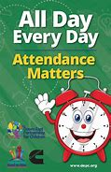
Attendance - Whole School Target 95%
This week’s whole school attendance is 92.1% with Year 2 in first place with 99.4% attendance. Llongyfarchiadau bawb! The half termly winners were Year 2 with 96.9%. Our ongoing school attendance is 94.2%. Our most improved attendance for the term is…Year 6!

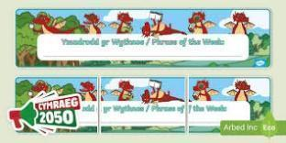
Welsh Phrase of the Week
In order to work towards our Bronze Award for the Siarter Iaith we are introducing the phrase of the week. Help your child by practising this at home.

W/B 2/06/25 - Beth wyt ti’n hoffi wneud? What do you want to do?
W/B 9/06/25 - Ga i chwarae…? Can I play? Ga i fynd…? Can I go?

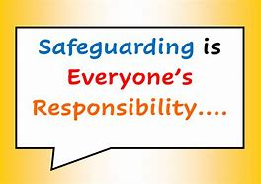
Safeguarding
Children’s welfare and wellbeing is at the heart of everything we do at Trelales.
Every person who works in the school has to have a DBS certificate and has annual training. The school’s safeguarding lead is Mr Gibson and deputy lead is Mrs Fitzgerald. If you have any concerns please raise them with a member of staff.
If you have concerns out in the community you can call MASH (Multi Agency Safeguarding Hub) on 01656 6422320. Alternatively, you can use this link to the website: Safeguarding

Photographing / filming children
Please can we remind all parents that if you want to take a photo / film of your child during school shows and events that it is only for your own personal viewing. It cannot be placed on any social media sites, particularly as other children may be in the photo / film.

District Schools Rugby Cup Final
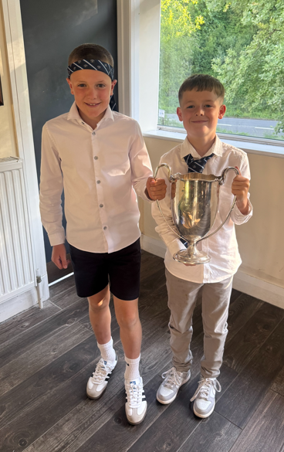
Huge congratulations to Morgan and Oscar who, along with the rest of the Bridgend District Schools Team, won the National Cup. They played Ponty at Rodney Parade and both played brilliantly helping the team win 25 - 15. It was a very close game which ebbed and flowed throughout.
Llongyfarchiadau boys, we are super proud of you both.

Family Engagement officer and Early Help.
Early Years and Young People Support Services
Bridgend County Borough Council has a service for families and organisations to refer to if they feel they need support with a range of concerns. The following link will take you to the webpage for further information. Our school has a family engagement officer who visits once a week, her contact details are on the flyer.
Bridgend Early Help Services - Bridgend CBC
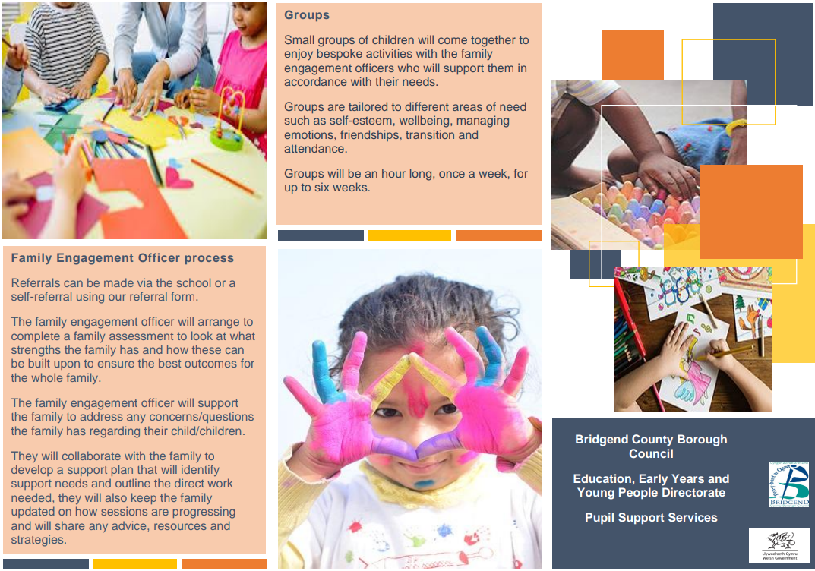

If you have any questions or require further information about any of the contents of this newsletter, don’t hesitate to contact us at: Admin.trelalesps@bridgened.cymru / 01656815611

